

Technology Stack: Cybersecurity with IBM Qradar

Project Title: Crafting customized monitoring solution with QRadar

Team ID:  LTVIP2024TMID15586

Team Members: 5

1. Medisetti Venkatesh

2. Pinapathruni Nani Babu

3. Koppisetti Venkatasurya

4. Moyilla Rajkumar

5. Desarla Suresh Arwan

College: P R Govt Degree (A), Kakinada

**INDEX**

|  |  |  |
| --- | --- | --- |
| SNO | TOPIC | Page |
| 1 | Introduction | 3 |
| 2 | Abstract | 4 |
| 3 | Stage-1 | 5 |
| 4 | Stage-2 | 23 |
| 5 | Stage-3 | 43 |
| 6 | Conclusion | 52 |
| 7 | Future Scope | 53 |
| 8 | Reference | 54 |

**INTRODUCTION**

In today's digital age, where cyber threats loom large and organizations face an ever-expanding array of risks, the need for robust cybersecurity measures has never been more critical. As technology continues to advance and businesses increasingly rely on interconnected systems and digital data, the potential impact of cyber attacks has grown exponentially. In response to this evolving threat landscape, organizations must adopt proactive approaches to cybersecurity, leveraging advanced tools and technologies to detect, analyze, and mitigate security incidents in real-time.

One such tool that has emerged as a cornerstone of modern cybersecurity operations is IBM QRadar. As a leading security information and event management (SIEM) solution, QRadar offers a comprehensive suite of features designed to help organizations monitor their IT infrastructure, identify potential threats, and respond effectively to security incidents. In this comprehensive guide, we will explore the various facets of IBM QRadar, from its core functionality and architecture to its deployment options and integration capabilities. We will delve into the key benefits of implementing QRadar within an organization, examine real-world use cases, and provide practical insights into optimizing its performance and effectiveness.

Before delving into the specifics of IBM QRadar, it is essential to first understand the current cybersecurity threat landscape and the challenges that organizations face in defending against cyber attacks. Today, cyber threats come in many forms, ranging from common malware and phishing attacks to sophisticated advanced persistent threats (APTs) and nation-state-sponsored cyber espionage campaigns. These threats can target various components of an organization's IT infrastructure, including networks, endpoints, applications, and data repositories.

One of the primary challenges in combating these threats is the sheer volume and complexity of security data generated by modern IT environments. Organizations generate vast amounts of security logs, event data, network traffic, and other telemetry from disparate sources, making it increasingly difficult to identify meaningful security incidents amidst the noise. Traditional security monitoring approaches often rely on manual analysis and correlation of these disparate data sources, leading to delays in detection and response.

This is where Security Information and Event Management (SIEM) solutions like IBM QRadar come into play. SIEM platforms are designed to aggregate, correlate, and analyze security data from across an organization's IT infrastructure, providing a centralized view of security events and incidents. By collecting data from sources such as firewalls, intrusion detection systems (IDS), antivirus solutions, and endpoint detection and response (EDR) tools, SIEMs enable organizations to detect suspicious activities, identify security breaches, and respond rapidly to mitigate the impact.

**ABSTRACT**

The project **“Crafting customized monitoring solution with IBM QRadar”** address In today's dynamic cybersecurity landscape, organizations are increasingly turning to sophisticated monitoring solutions to bolster their defenses against evolving threats. Among these, IBM QRadar stands out as a powerful platform offering comprehensive capabilities for threat detection, incident response, and compliance management. This project delves into the process of crafting customized monitoring solutions with IBM QRadar, leveraging its advanced features and flexible architecture to address the unique security requirements of organizations across diverse industries.

The project commences with an exploration of the core functionalities of IBM QRadar, elucidating its event collection mechanisms, real-time processing engine, advanced analytics, and threat intelligence integration capabilities. By understanding the foundational elements of QRadar, organizations can lay the groundwork for building tailored monitoring solutions that align with their specific security objectives and operational needs.

Collaboration and knowledge sharing play a critical role in the success of customized monitoring solutions with QRadar. The project explores best practices for fostering collaboration between cybersecurity teams, IT operations, and business stakeholders, emphasizing the importance of communication, training, and continuous improvement. By fostering a culture of collaboration and empowerment, organizations can maximize the value derived from QRadar and stay ahead of emerging threats.

The project culminates in a series of case studies and success stories showcasing the effectiveness of customized monitoring solutions with QRadar in real-world scenarios. These case studies demonstrate how organizations across different industries have leveraged QRadar to enhance their security posture, streamline their operations, and respond effectively to security incidents. Insights and best practices gleaned from these case studies offer valuable guidance for organizations embarking on their QRadar journey.

Integration plays a crucial role in the customization process, as organizations seek to leverage existing security investments and infrastructure alongside IBM QRadar. The project explores QRadar's integration capabilities with third-party security tools, network devices, cloud platforms, and threat intelligence feeds. By seamlessly integrating QRadar with existing security infrastructure, organizations can enhance their visibility, detection capabilities, and incident response workflows.

Real-world use cases and success stories serve to illustrate the practical applications of customized monitoring solutions with IBM QRadar. From insider threat detection and compliance monitoring to advanced persistent threat (APT) detection and incident response, QRadar proves its adaptability and effectiveness in diverse scenarios. These use cases provide inspiration and guidance for organizations seeking to leverage QRadar to address their unique security challenges

**STAGE-1**

**Topic:- Understanding Planning and requirements gathering and Data Analysis**

**REPORT**

**Planning and requirements gathering**

Planning and requirement gathering are critical phases in the development of any project, be it software, infrastructure, or even a business venture. These initial stages lay the foundation for success by defining the scope, objectives, resources, and constraints of the project. Let's delve into these concepts in detail.

Planning involves creating a roadmap that outlines the steps needed to achieve the project's goals. It starts with understanding the project's purpose and identifying stakeholders' expectations. This phase requires clear communication and collaboration among team members to gather insights into the project's scope, budget, timeline, and risks.

Requirement gathering is a systematic process of collecting, analyzing, and documenting stakeholders' needs and expectations. It involves conducting interviews, surveys, workshops, and reviews to gather information. The goal is to create a detailed and accurate set of requirements that serve as a blueprint for the project's development.

The planning phase typically begins with a project initiation stage, where the project's objectives, scope, and stakeholders are identified. This stage sets the project's direction and establishes a framework for decision-making throughout the project lifecycle. Key activities in this stage include defining project goals, identifying constraints, and establishing success criteria

Once the project initiation is complete, the next step is to develop a comprehensive project plan. This plan includes defining project scope, creating a work breakdown structure (WBS), identifying resources, estimating costs and timelines, and establishing quality criteria. The project plan serves as a guide for project execution, monitoring, and control.

Effective requirement gathering is essential for project success. It involves understanding stakeholders' needs, expectations, and constraints. This process requires active listening, asking the right questions, and documenting requirements accurately. Key activities in requirement gathering include stakeholder identification, requirement elicitation, analysis, validation, and documentation

Stakeholder identification involves identifying all parties involved in or affected by the project. This includes internal stakeholders such as project sponsors, team members, and end-users, as well as external stakeholders such as customers, vendors, and regulatory bodies.

Requirement elicitation is the process of gathering requirements from stakeholders through various techniques such as interviews, surveys, observations, and workshops. This phase focuses on understanding stakeholders' needs, goals, priorities, and constraints.

Once requirements are gathered, they need to be analyzed to ensure clarity, completeness, consistency, and feasibility. This involves prioritizing requirements, resolving conflicts, and validating them against business objectives and constraints.

Validation is a crucial step to ensure that requirements are accurate, verifiable, and aligned with stakeholders' expectations. This may involve prototyping, simulations, reviews, and walkthroughs to validate requirements before they are finalized.

Finally, requirements are documented in a requirements specification document (RSD) or a requirements management tool. This document serves as a reference for project planning, design, development, testing, and validation activities. In conclusion, planning and requirement gathering are essential phases in project management that lay the groundwork for project success. They involve defining project objectives, scope, resources, and constraints, as well as gathering and documenting stakeholders' needs and expectations. Effective planning and requirement gathering contribute to better project outcomes reduced risks, and increased stakeholder satisfaction

**IDENTIFYING MONITORING OBJECTIVES AND GOALS**

Identifying monitoring objectives and goals is a crucial aspect of project management and organizational development. Monitoring objectives and goals involve setting clear targets and defining key performance indicators (KPIs) to measure progress, track performance, and ensure that projects and processes align with strategic objectives. Let's delve into this topic in detail

Monitoring objectives and goals begin with a clear understanding of the organization's mission, vision, and strategic objectives. These high-level statements define what the organization aims to achieve and provide a framework for setting specific, measurable, achievable, relevant, and time-bound (SMART) goals.

The first step in identifying monitoring objectives and goals is to conduct a thorough assessment of the current state of affairs. This includes reviewing existing processes, systems, and performance metrics to identify strengths, weaknesses, opportunities, and threats. This assessment helps in identifying areas that require improvement, optimization, or realignment with strategic priorities.

Once the current state assessment is complete, the next step is to define monitoring objectives. Monitoring objectives are specific outcomes or results that the organization aims to achieve within a certain timeframe. These objectives should be aligned with the organization's strategic priorities and SMART criteria. For example, a monitoring objective for a project could be to increase customer satisfaction by 20% within the next six months.

After defining monitoring objectives, the next step is to establish goals and KPIs. Goals are specific targets or milestones that support the achievement of monitoring objectives. They provide a clear direction and focus for monitoring and evaluation activities. KPIs, on the other hand, are measurable metrics that track progress towards achieving goals. They help in quantifying performance, identifying trends, and making data-driven decisions.

When setting goals and KPIs, it's important to consider the following factors:

1. Relevance: Goals and KPIs should be directly linked to monitoring objectives and strategic priorities. They should address critical areas that impact the organization's success.

2. Measurability: Goals and KPIs should be quantifiable and measurable using reliable data sources. This ensures that progress can be tracked accurately over time.

3. Achievability: Goals should be challenging yet realistic. They should stretch the organization's capabilities without being overly ambitious or unattainable.

4. Time-bound: Goals and KPIs should have specific timeframes or deadlines for achievement. This creates a sense of urgency and accountability.

5. Alignment: Goals and KPIs should be aligned with stakeholders' expectations, resources, and constraints. They should reflect a shared understanding of what success looks like.

Once goals and KPIs are defined, the next step is to develop a monitoring and evaluation plan. This plan outlines the processes, tools, responsibilities, and timelines for monitoring progress, collecting data, analyzing results, and reporting findings. It also specifies how feedback will be used to make informed decisions and improve performance.

Effective monitoring and evaluation require ongoing tracking, analysis, and reporting of performance data. This involves regular reviews of KPIs, comparing actual results against targets, identifying trends and patterns, and taking corrective actions as needed. It also involves communicating progress, achievements, challenges, and lessons learned to stakeholders at all levels of the organization.

**ASSESSING NETWORK INFRASTRUCTURE AND ARCHITECTURE**

Assessing network infrastructure and architecture is a critical aspect of maintaining a robust and efficient IT environment. It involves evaluating the design, components, performance, security, and scalability of a network to ensure it meets current and future business requirements. Let's explore this topic in detail.

Network infrastructure assessment starts with a comprehensive review of the existing network architecture. This includes examining the network topology, hardware devices (such as routers, switches, firewalls, and servers), software components (like operating systems, network protocols, and applications), cabling, and connectivity options. The goal is to understand how data flows within the network, identify potential bottlenecks or vulnerabilities, and assess the overall network health.

One key aspect of network assessment is performance evaluation. This involves measuring factors such as bandwidth utilization, latency, packet loss, throughput, and network congestion. Performance testing tools and techniques, such as network monitoring software, traffic analysis, and load testing, help in gathering data and identifying areas for optimization or improvement.

Security is another critical area of network assessment. It involves evaluating the network's defenses against cyber threats, unauthorized access, data breaches, malware, and other security risks. This includes reviewing firewall configurations, access control policies, encryption protocols, intrusion detection/prevention systems (IDS/IPS), and security patches/updates. Vulnerability assessments and penetration testing can also be conducted to identify and remediate security weaknesses.

Scalability assessment is essential for ensuring that the network can accommodate future growth, increased traffic, new applications, and expanding user base. It involves evaluating the network's capacity, performance under load, scalability of hardware/software components, and ability to support emerging technologies (such as cloud computing, Internet of Things, and 5G networks). Capacity planning and forecasting help in determining when and how to scale network resources effectively.

Network architecture assessment also includes reviewing network management practices, policies, and procedures. This involves assessing the effectiveness of network monitoring, configuration management, change control, incident response, and disaster recovery plans. It's crucial to ensure that network management tools and practices align with industry best practices and compliance requirements (such as GDPR, HIPAA, PCI DSS, etc.).

Another aspect of network assessment is cost-effectiveness. This involves evaluating the total cost of ownership (TCO) of the network infrastructure, including initial investments, maintenance costs, upgrades, licensing fees, and operational expenses. Cost-benefit analysis helps in determining the ROI of network investments and identifying opportunities for cost savings or optimization.

**DEFINING KEY PERFORMANCE INDICATORS (KPIS)**

Defining Key Performance Indicators (KPIs) is crucial for organizations to measure progress, track performance, and achieve their strategic objectives. KPIs are quantifiable metrics that help in evaluating the success of an organization, department, project, or individual against predefined goals and targets. Let's delve into this topic in detail.

1.Strategic Alignment: KPIs should be directly linked to the organization's strategic objectives, mission, and vision. They should reflect what matters most to the organization and align with its long-term goals. For example, if the strategic goal is to increase market share, relevant KPIs could include market share percentage, customer acquisition rates, or customer retention rates.

2. Measurability: KPIs must be measurable using reliable data sources. They should provide quantitative insights into performance and progress. Measurable KPIs enable organizations to track trends, identify patterns, and make data-driven decisions. For instance, if the goal is to improve customer satisfaction, measurable KPIs could include Net Promoter Score (NPS), customer feedback ratings, or complaint resolution times.

3. Relevance: KPIs should be relevant to the specific area or process being measured. They should focus on critical aspects that directly impact organizational success. For example, in sales, relevant KPIs may include revenue growth, sales conversion rates, average deal size, or sales pipeline velocity.

4. Achievability: KPIs should be realistic and achievable within a given timeframe. They should challenge performance without being overly ambitious or unattainable. Setting achievable KPIs motivates teams and individuals to strive for excellence while maintaining a sense of feasibility.

5. Time-bound: KPIs should have specific timeframes or deadlines for achievement. Time-bound KPIs create a sense of urgency and accountability, driving action and progress. For instance, setting quarterly or annual targets for

6.Actionability: KPIs should be actionable, meaning they should provide insights that lead to tangible actions and improvements. Actionable KPIs help in identifying areas for optimization, problem-solving, and performance enhancement. For example, if the KPI is customer churn rate, actionable insights may include analyzing reasons for churn and implementing retention strategies.

7.Consistency: KPIs should be consistent over time to enable meaningful comparisons and trend analysis. Consistent KPIs allow organizations to track performance progress, identify deviations, and adjust strategies accordingly. For instance, maintaining consistent KPIs for sales performance enables year-over-year comparisons and trend analysis.

8. Balance: KPIs should provide a balanced view of performance across multiple dimensions. They should not focus solely on financial metrics but also include non-financial indicators such as customer satisfaction, employee engagement, innovation, sustainability, and operational efficiency. A balanced set of KPIs provides a holistic view of organizational performance.

9. Ownership: Each KPI should have a clear owner or responsible party who is accountable for its measurement, analysis, and improvement. Assigning ownership ensures accountability and empowers individuals or teams to take ownership of their performance outcomes.

10. Continuous Review and Improvement: KPIs should be regularly reviewed, evaluated, and updated as needed. Continuous review allows organizations to adapt to changing business environments, market conditions, and strategic priorities. It also enables continuous improvement by identifying areas for enhancement and refinement of KPIs based on feedback and insights.

In conclusion, defining Key Performance Indicators (KPIs) involves strategic alignment, measurability, relevance, achievability, time-bound nature action, consistency, balance, ownership, and continuous review and improvement. By defining KPIs that align with organizational goals and provide actionable insights, organizations can effectively measure and improve performance, drive success, and achieve their desired outcomes.

**IDENTIFYING CRITICAL APPLCATIONS AND SERVICES**

Identifying critical applications and services is a crucial task for organizations to ensure the uninterrupted functioning of essential business processes and maintain high levels of productivity and customer satisfaction. Critical applications and services are those that are vital to the core operations, revenue generation, regulatory compliance, customer service, and overall success of an organization. Let's delve into this topic in detail.

1. Business Impact Analysis (BIA): Conducting a Business Impact Analysis is a fundamental step in identifying critical applications and services. BIA involves assessing the potential impact of disruptions or outages on various business functions, processes, and stakeholders. It helps in prioritizing applications and services based on their importance to business continuity, revenue generation, customer service, regulatory compliance, and reputation.

2. Stakeholder Consultation: Engaging with key stakeholders across different departments and levels of the organization is essential for identifying critical applications and services. Stakeholders, including business leaders, department heads, IT managers, and end-users, can provide valuable insights into the importance of specific applications and services for daily operations, strategic objectives, and customer interactions.

3. Regulatory and Compliance Requirements: Organizations must consider regulatory and compliance requirements when identifying critical applications and services. Applications and services that support compliance with industry regulations, data protection laws, privacy standards, and security protocols are often deemed critical due to the legal and financial implications of non-compliance.

4. Revenue Generation: Applications and services directly involved in revenue generation, sales, invoicing, payment processing, and financial transactions are typically classified as critical. Any disruption to these systems can

**ESTABLISHING COMPIIANCE AND REGULATORY REQUIREMENTS**

Establishing compliance and regulatory requirements is a fundamental aspect of organizational governance, ensuring that businesses operate within legal frameworks, industry standards, and ethical guidelines. Compliance encompasses adherence to laws, regulations, policies, and industry best practices relevant to an organization's operations, products, services, and stakeholders. Let's explore the process of establishing compliance and regulatory requirements in detail.

1. Legal Landscape Analysis: The first step in establishing compliance and regulatory requirements is conducting a comprehensive analysis of the legal landscape applicable to the organization. This involves identifying relevant laws, regulations, statutes, ordinances, and directives at the local, national, and international levels. Legal areas may include data protection, consumer rights, intellectual property, employment laws, environmental regulations, financial reporting, and industry-specific standards.

2. Industry Standards and Best Practices: Organizations must also consider industry-specific standards, guidelines, and best practices that govern their sector. Industry standards may be set by regulatory bodies, industry associations, standards organizations, or consensus frameworks. Adhering to industry standards ensures alignment with peers, promotes interoperability, enhances credibility, and supports competitive advantage.

3. Risk Assessment: Conducting a risk assessment helps in identifying potential compliance risks, vulnerabilities, and gaps within the organization. Risks may stem from regulatory changes, non-compliance penalties, data breaches, legal disputes, reputational damage, operational disruptions, or third-party relationships. Risk assessment involves evaluating the likelihood and impact of risks and prioritizing mitigation strategies.

4. Internal Policies and Procedures: Establishing internal policies, procedures, and controls is essential for ensuring compliance and regulatory adherence. Organizations develop policies that outline expectations, responsibilities, guidelines, and protocols for employees, contractors, suppliers, and stakeholders. Policies cover areas such as data privacy, security protocols, anti-corruption, code of conduct, reporting mechanisms, and disciplinary actions.

5. Compliance Frameworks: Implementing a compliance framework provides a structured approach to managing compliance requirements. Common compliance frameworks include COSO (Committee of Sponsoring Organizations of the Treadway Commission), ISO 27001 (Information Security Management System), NIST (National Institute of Standards and Technology) Cybersecurity Framework, GDPR (General Data Protection Regulation), HIPAA (Health Insurance Portability and Accountability Act), PCI DSS (Payment Card Industry Data Security Standard), and SOX (Sarbanes-Oxley Act).

6. Training and Awareness: Training programs and awareness campaigns are vital for educating employees, managers, and stakeholders about compliance requirements, policies, procedures, and ethical standards. Training covers topics such as data protection, cybersecurity awareness, anti-money laundering (AML), anti-bribery and corruption (ABC), conflict of interest, discrimination, workplace safety, and regulatory updates.

7. Compliance Monitoring and Auditing: Establishing compliance monitoring and auditing mechanisms helps in assessing ongoing adherence to regulatory requirements and internal policies. Monitoring involves real-time tracking of key performance indicators (KPIs), metrics, incidents, and compliance violationns. Auditing involves independent reviews, assessments, and examinations of compliance controls, processes, documentation, and evidence.

8. Incident Response and Remediation: Developing incident response plans and remediation strategies prepares organizations to address compliance breaches, incidents, and non-conformities effectively. Incident response plans outline escalation procedures, communication protocols, containment measures, forensic investigations, root cause analysis, corrective actions, and reporting to regulatory authorities, if required.

9. Third-Party Risk Management: Organizations must also manage compliance risks associated with third-party vendors, suppliers, contractors, and partners. This includes conducting due diligence, contract reviews, compliance assessments, audits, monitoring third-party activities, and enforcing compliance clauses in agreements. Third-party risk management ensures that external entities comply with legal, regulatory, and contractual obligations.

10. Continuous Improvement: Compliance is an ongoing process that requires continuous monitoring, evaluation, and improvement. Organizations should establish mechanisms for feedback, reviews, performance evaluations, lessons learned, corrective actions, and updates to compliance programs. Continuous improvement ensures that compliance efforts remain effective, adaptive to changes, and aligned with organizational goals.

**DATA ANALYSIS AND PROCESSING**

Data Analysis And Processing

Crafting a customized solution with QRadar involves a structured approach to data analysis and processing tailored to specific security needs. It begins with understanding stakeholder requirements and defining the scope of data to be collected and analyzed. Data collection entails identifying sources such as logs and network traffic, and configuring QRadar to ingest this data. Normalization and parsing rules ensure that disparate data formats are unified for analysis, while enrichment with external sources provides additional context for threat detection. Correlation rules are then developed to identify security incidents and anomalies, with custom rules and offenses crafted to address unique organizational concerns. Visualization through dashboards and reports enhances visibility into security events and trends, supporting informed decision-making and compliance reporting. Integration with other security tools and systems extends QRadar's capabilities, while continuous monitoring and optimization ensure the solution remains effective in detecting and responding to evolving threats. This iterative process requires collaboration between security experts, IT teams, and stakeholders to align the solution with organizational goals and adapt to changing security landscapes. 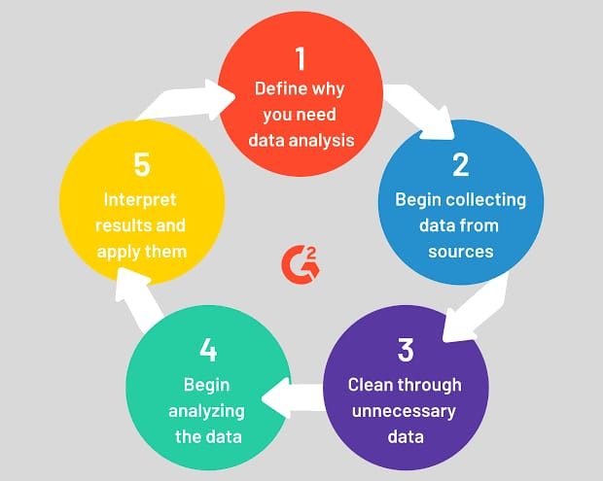

**Parsing and decoding packet data:**

Parsing and decoding packet data is a crucial aspect of network security andanalysis, especially within the context of solutions like QRadar. In this process, raw network packets are dissected and interpreted to extract relevant information for further analysis. QRadar employs various techniques to achieve this:

1. Packet Capture: Initially, network packets are captured using mechanisms like port mirroring, network taps, or packet sniffers.

2. Protocol Identification: Each packet is examined to identify the protocol it belongs to, such as TCP, UDP, ICMP, etc.

3. Packet Parsing: QRadar parses the packet headers to extract key information like source and destination IP addresses, port numbers, sequence numbers, flags, and payload length.

4. Payload Analysis: The payload of the packet is inspected to extract higher-level information, such as HTTP requests, DNS queries, or file transfers.

5. Decoding: QRadar decodes encoded or encrypted data within the packets to reveal their contents, which may include malware, command and control communication, or sensitive information.

6. Normalization: Once decoded, the data is normalized to ensure consistency across different packet formats and protocols.

7. Enrichment: Additional context is added to the parsed data through integration with external sources, such as threat intelligence feeds or asset databases.

8. Correlation: Parsed and decoded packet data is correlated with other security events to identify patterns, anomalies, and potential security threats.

QRadar's capabilities in parsing and decoding packet data enable it to effectively monitor and analyze network traffic, detect suspicious activities, and respond to security incidents in real-time. This process plays a critical role in identifying and mitigating cybersecurity risks within an organization's network infrastructure**.**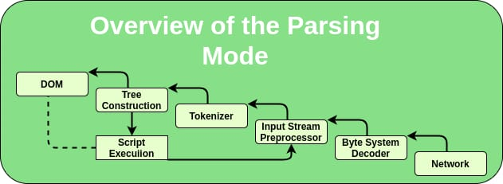

**Extracting Relevant Information And Metrics:**

Analysing and extracting relevant information and metrics from parsed packet data is crucial for gaining insights into various aspects of network performance, application behavior, and security posture. By capturing key indicators such as bandwidth utilization, response times, error rates, and transaction volumes, organizations can assess the health and efficiency of their network services. This process involves utilizing specialized tools and techniques to parse packet data, extract pertinent information, and analyze it to derive actionable insights.

Extracting relevant information and metrics from parsed packet data is essential for several reasons:

1. Performance Monitoring: By analyzing metrics such as bandwidth utilization and response times, network administrators can identify bottlenecks, optimize resource allocation, and ensure smooth operation of critical services.

2. Security Analysis: Packet data contains valuable information about network traffic patterns, which can be used to detect anomalous behavior, identify potential security threats such as intrusions or malware, and strengthen defense mechanisms.

3. Application Insights: Understanding how applications behave within the network environment is crucial for optimizing performance, troubleshooting issues, and ensuring a seamless user experience.

4. Capacity Planning: By analyzing transaction volumes and trends over time, organizations can forecast future demand, allocate resources effectively, and avoid performance degradation due to overloading.

Tools and Techniques for Packet Data Analysis

Several tools and techniques are available for analyzing packet data and extracting relevant information:

1. Packet Sniffers: Tools like Wireshark, tcpdump, and tshark capture and analyze network traffic in realtime, allowing users to inspect individual packets, extract data payloads, and apply filters to focus on specific protocols or communication patterns.

2. Flow Analysis: Flowbased analysis tools such as NetFlow, sFlow, and IPFIX aggregate packet data into flow records, providing insights into traffic volume, communication patterns, and protocol usage without the need to inspect every packet.

3. Deep Packet Inspection (DPI): DPI tools examine packet payloads at the application layer, allowing for advanced analysis of application behavior, content filtering, and intrusion detection.

4. Machine Learning: Advanced analytics techniques, including machine learning algorithms, can be applied to packet data to identify patterns, anomalies, and trends indicative of performance issues or security threats.

Key Metrics for Network Performance Monitoring

When extracting information from packet data for network performance monitoring, several key metrics should be considered:

1. Bandwidth Utilization: Measure the amount of network bandwidth consumed by different protocols, applications, or devices to identify congestion points and optimize resource allocation.

2. Response Times: Analyze the time taken for network requests to receive a response, including roundtrip times for clientserver communication and latency introduced by network devices.

3. Error Rates: Monitor packet loss, retransmission rates, and other indicators of communication errors to identify potential issues with network reliability and quality of service.

4. Throughput: Measure the rate of data transfer between endpoints to ensure that network capacity meets demand and identify opportunities for optimization.

5. Jitter and Packet Delay Variation (PDV): Assess the variability in packet delivery times to ensure smooth, predictable performance for realtime applications such as voice and video.

6. Network Latency: Measure the time taken for data packets to travel between source and destination, including propagation delay, transmission delay, and processing delay.

Key Metrics for Security Analysis

In addition to performance monitoring, extracting information from packet data is crucial for detecting and mitigating security threats. Key metrics for security analysis include:

1. Traffic Patterns: Identify unusual or suspicious patterns in network traffic, such as unexpected communication channels, abnormal packet sizes, or spikes in activity.

2. Protocol Anomalies: Detect deviations from expected protocol behavior, including malformed packets, unauthorized protocol usage, or unusual command sequences.

3. Signaturebased Detection: Match packet payloads against known signatures of common threats, such as viruses, worms, or exploit attempts, to identify and block malicious activity.

4. Behavioral Analysis: Use machine learning algorithms to analyze network behavior over time and identify anomalies indicative of potential security breaches, such as insider threats or advanced persistent threats.

5. Encryption Analysis: Decrypt encrypted traffic to inspect payload contents for signs of malicious activity, such as commandandcontrol communication or data exfiltration.

6. User Authentication and Authorization: Analyze authentication protocols and user access patterns to detect unauthorized access attempts or credential misuse.

Challenges and Considerations

While extracting information and metrics from packet data offers valuable insights into network performance and security, several challenges and considerations must be addressed:

1. Data Volume: Networks generate vast amounts of packet data, requiring efficient storage, processing, and analysis capabilities to extract meaningful insights without overwhelming resources.

2. Privacy Concerns: Packet data may contain sensitive information, such as user credentials or personal data, requiring careful handling to ensure compliance with privacy regulations and protection against unauthorized access.

3. Complexity: Analyzing packet data often involves dealing with diverse protocols, communication patterns, and network configurations, requiring expertise in networking, security, and data analysis.

4. Realtime Monitoring: In environments where realtime responsiveness is crucial, such as critical infrastructure or online services, packet analysis tools must provide timely insights to enable rapid decisionmaking and response.

5. Resource Constraints: Deploying packet analysis tools may impose additional overhead on network resources, requiring careful optimization and resource allocation to minimize impact on performance.

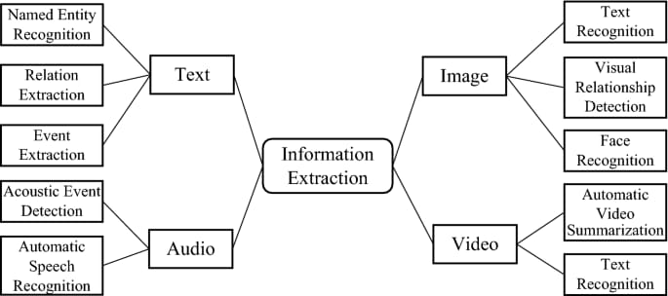

**Analyzing Application Protocols And Traffic Patterns:**

Analyzing Application Protocols And Traffic laying applicationlayer protocols and traffic patterns is crucial for understanding the behavior of networked applications and services. This process involves examining the communication protocols used by applications, observing the traffic patterns they generate, and identifying anomalies or deviations from normal behavior. By establishing a baseline of normal activity and using statistical analysis and machine learning techniques, network administrators can detect potential performance issues or security threats.

Understanding Applicationlayer Protocols

This section will delve into various applicationlayer protocols commonly used in networked environments. It will cover protocols such as HTTP, HTTPS, FTP, SMTP, DNS, and others, explaining their purposes, characteristics, and typical traffic patterns.

Analyzing Traffic Patterns

Here, we will discuss different types of traffic patterns that can be observed in network traffic, including regular, irregular, and anomalous patterns. We will explore how traffic patterns can vary based on factors such as time of day, user behavior, application usage, and network topology.

Establishing Baseline Behavior

This section will focus on the importance of establishing a baseline of normal behavior for networked applications. It will discuss techniques for capturing and analyzing network traffic to create a baseline, including packet capture, flow analysis, and log analysis.

Detecting Anomalies

Using statistical analysis and machine learning techniques, network administrators can detect anomalies and deviations from expected traffic patterns. This section will explore various anomaly detection methods, such as thresholdbased detection, clustering, and classification algorithms.

Performance Monitoring

Monitoring applicationlayer protocols and traffic patterns is essential for ensuring optimal network performance. This section will discuss how traffic analysis can be used to identify performance bottlenecks, optimize resource allocation, and improve overall network efficiency.

Security Threat Detection

One of the primary reasons for analyzing applicationlayer protocols and traffic patterns is to identify security threats. This section will explore common security threats that can be detected through traffic analysis, including malware infections, data exfiltration, DDoS attacks, and insider threats.

Incident Response and Remediation

When anomalies or security threats are detected, network administrators must respond promptly to mitigate the risks. This section will discuss incident response procedures, including containment, eradication, and recovery steps, as well as preventive measures to minimize future incidents.

Case Studies and Realworld Examples

To illustrate the practical application of traffic analysis techniques, this section will present case studies and realworld examples of how organizations have used traffic analysis to address performance issues and security threats.

Challenges and Future Trends.

**Correlating Events And Anomalies:**

Correlating Events And Anomalies

Correlate events and anomalies detected from packet data with other security and operational telemetry sources to provide context and identify potential causeandeffect relationships. Use correlation rules and algorithms to link related events across different data sources and uncover hidden patterns or trends indicative of malicious activity or system malfunctions.

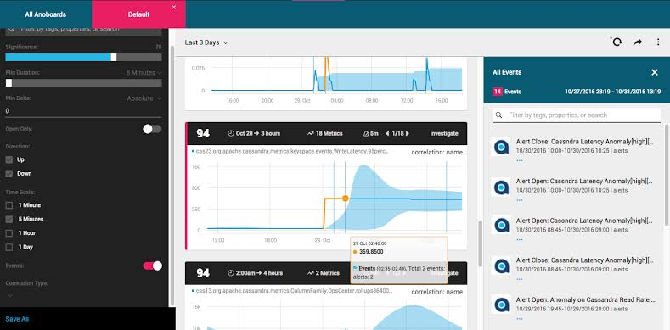

**Identifying Security Threats And Intrusions:**

Analyzing packet data to identify and mitigate security threats and intrusions is a critical aspect of cybersecurity. By examining the contents of network packets, security professionals can uncover indicators of compromise (IOCs), detect suspicious behaviors, and recognize known attack signatures within the packet payload. This proactive approach allows organizations to strengthen their defenses and safeguard their networks and applications against cyber threats.

Understanding Packet Data Analysis

Packet data analysis involves inspecting the individual packets of data that traverse a network. These packets contain information such as source and destination addresses, protocol type, and payload data. By capturing and analyzing this data, security analysts can gain insights into the activities occurring within their network and identify potential security threats.

Components of Packet Data

1. Header Information: Each packet contains header information, including source and destination IP addresses, port numbers, and protocol type (e.g., TCP, UDP).

2. Payload Data: The payload carries the actual content being transmitted, which could include email messages, file transfers, or web page data.

3. Timestamps: Timestamps provide information about when each packet was sent or received, aiding in the reconstruction of events during an investigation.

Identifying Security Threats

Indicators of Compromise (IOCs)

IOCs are artifacts or activities that indicate a security incident has occurred or is in progress. These may include:

Malware Signatures: Patterns or characteristics of known malware within packet payloads.

Anomalous Network Traffic: Unusual patterns of network traffic that deviate from normal behavior.

Unauthorized Access Attempts: Multiple failed login attempts or access to sensitive resources from unusual locations.

Suspicious Behaviors

Certain behaviors within packet data may raise suspicion and warrant further investigation:

Data Exfiltration: Large volumes of data being transferred to external or unauthorized destinations.

Command and Control (C2) Communication: Communication with known malicious IP addresses or domains associated with botnets or C2 servers.

DNS Tunneling: Attempts to bypass network security by embedding data within DNS queries and responses.

Known Attack Signatures

Security analysts often rely on databases of known attack signatures to identify threats within packet data:

Intrusion Detection Signatures: Patterns of network activity associated with specific types of attacks, such as SQL injection or crosssite scripting (XSS).

Exploit Payloads: Code or commands embedded within packet payloads designed to exploit vulnerabilities in target systems.

Malicious Domains or IP Addresses: Blacklisted domains or IP addresses associated with malicious activity.

Mitigating Security Threats

Threat Intelligence Feeds

Threat intelligence feeds provide realtime information about emerging threats and known malicious entities. By integrating these feeds into their security infrastructure, organizations can:

Identify Emerging Threats: Receive alerts about new malware strains, vulnerabilities, or attack techniques.

Block Malicious Traffic: Automatically block access to known malicious domains or IP addresses.

Prioritize Threat Response: Allocate resources based on the severity and relevance of identified threats.

Behavioral Analysis Techniques

Behavioral analysis involves monitoring network traffic for patterns of behavior indicative of a security threat. This approach focuses on:

Anomaly Detection: Identifying deviations from normal network behavior, such as sudden spikes in traffic or unusual access patterns.

User and Entity Behavior Analytics (UEBA): Analyzing user behavior to detect insider threats or unauthorized access attempts.

Machine Learning Algorithms: Training algorithms to recognize patterns associated with specific types of attacks and adapt to new threats over time.

Proactive Defense Strategies

In addition to reactive threat detection and mitigation, organizations can adopt proactive defense strategies to strengthen their security posture:

Vulnerability Management: Regularly scan systems for known vulnerabilities and apply patches or updates to mitigate risk.

Security Awareness Training: Educate employees about common security threats and best practices for maintaining a secure computing environment.

Incident Response Planning: Develop and regularly test incident response plans to ensure a swift and coordinated response to security incidents.

Here the following packet capture data of the Wikipedia website

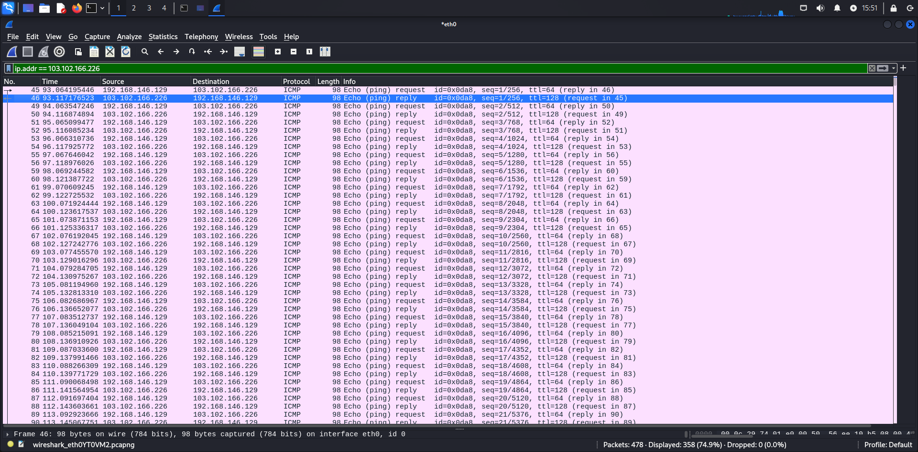

Follow this steps

* Goto Google and type Wikipedia
* Then copy the url
* <https://www.wikipedia.org/>
* Open command promt and type
* ping [www.wikipedia.org](http://www.wikipedia.org)
* Then you got the specific ip addr of the website
* Now select ip and open wireshark application on kali/windows
* Enter ip on filter box like this
* Ip addr==103.102.166.226 and press enter(on wireshark application)

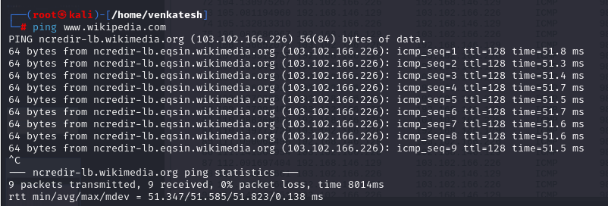

**STAGE-2**

**Topic:- Performing Packet caputure and Alert and Notification System**

**PACKET CAPTURE AND DATA COLLECTION**

Packet capture involves intercepting and logging data packets that traverse a computer network. It's typically done using specialized software or hardware devices called packet sniffers or network analyzers. These tools capture packets at various points in the network and store them for analysis.

**Purposes of Packet Capture:**

1. **Network Troubleshooting:** Capturing packets helps identify network issues such as latency, packet loss, and misconfigurations.
2. **Security Analysis:** Packet capture aids in detecting and investigating security incidents, such as intrusion attempts, malware infections, and data breaches.
3. **Performance Monitoring:** Analyzing packet data can reveal patterns of network usage, application behavior, and performance bottlenecks.
4. **Compliance and Forensics:** Captured packets can serve as evidence in forensic investigations and compliance audits, helping to reconstruct events and analyze network activity.

**Packet Capture Tools:**

* **Wireshark:** A popular open-source packet analyzer with extensive protocol support and customizable filters.

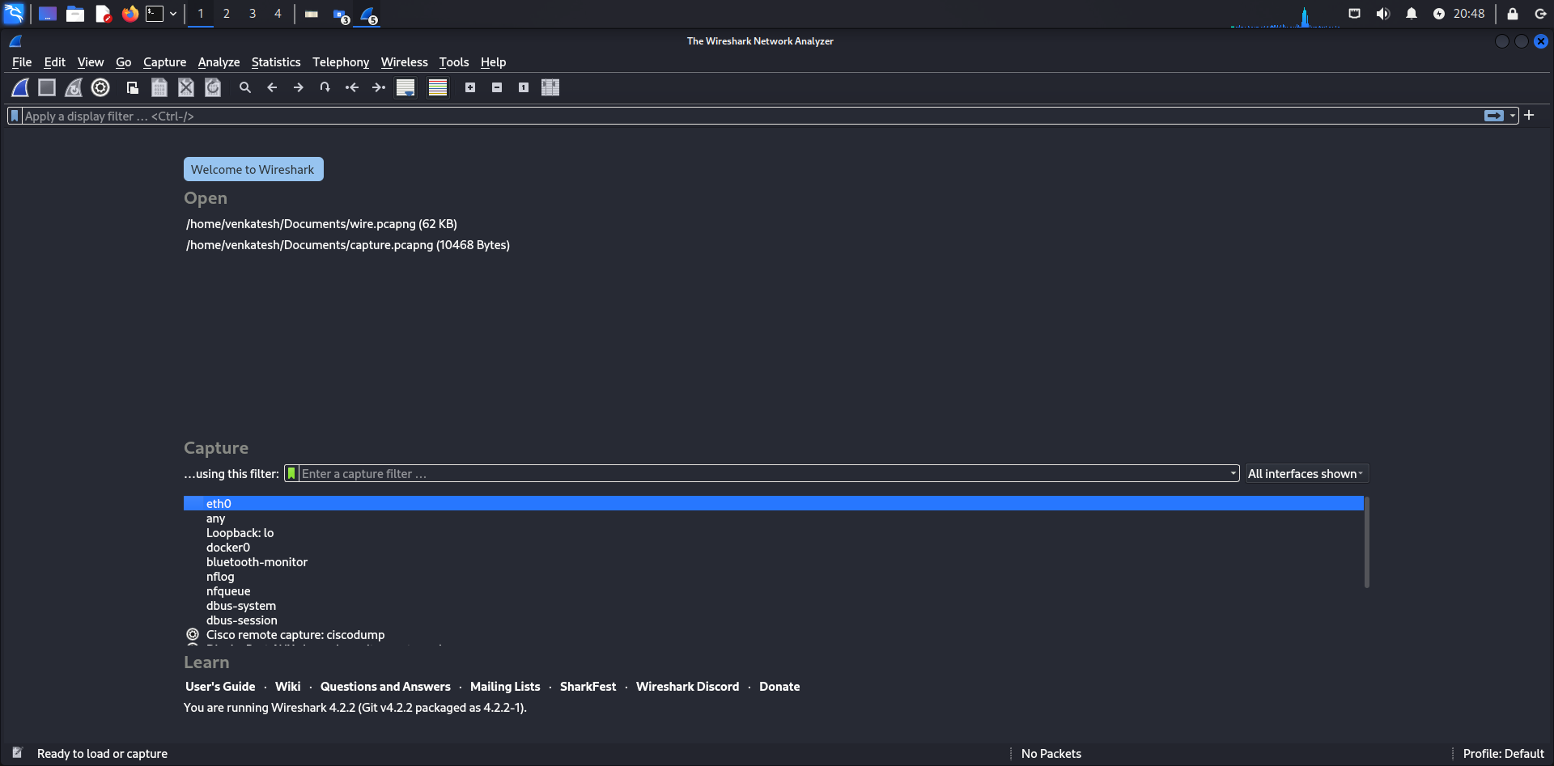

**Data Collection:**

Data collection in the context of networking involves gathering various types of data related to network traffic, performance, and security events. This data can come from packet captures, log files, SNMP (Simple Network Management Protocol) metrics, flow data (e.g., NetFlow, sFlow), and other sources.

**Types of Data Collected:**

1. **Packet Data:** Raw packet captures containing detailed information about network traffic, including headers and payloads.
2. **Log Data:** System logs, application logs, and security logs that record events and activities on network devices and servers.
3. **Flow Data:** Aggregated records summarizing communication flows between network endpoints, including source and destination IPs, ports, and protocols.
4. **Performance Metrics:** Metrics such as bandwidth utilization, latency, jitter, and error rates collected using SNMP or other monitoring protocols.
5. **Security Events:** Alerts and logs generated by security devices (e.g., firewalls, IDS/IPS) indicating suspicious or malicious activity on the network.

**Data Collection Tools:**

* Log Management Systems: Platforms for collecting, storing, and analyzing log data from various sources.
* Network Monitoring Tools: Solutions that collect and visualize network performance metrics, flow data, and other relevant information.
* SIEM (Security Information and Event Management) Systems: Integrated platforms for collecting, correlating, and analyzing security event data from multiple sources.
* Custom Scripts and APIs: Tools developed in-house or using third-party APIs to extract specific data from network devices and applications.

**SELECTING PACKET CAPTURE SOLUTIONS AND TOOLS**

**1. Requirements Analysis:**

* Define your objectives: Determine why you need packet capture (network troubleshooting, security analysis, performance monitoring, etc.).
* Consider scalability: Will you need to capture packets on a small LAN or a large enterprise network?
* Compliance needs: Ensure the solution complies with relevant regulations (e.g., GDPR, hipaa).

**2. Ease of Use and Interface:**

* User-friendly interface: Especially important if you have a diverse team with varying levels of technical expertise.
* Customization options: Ability to tailor capture settings according to your needs.

**3. Compatibility:**

* Ensure compatibility with your network infrastructure and protocols (e.g., TCP/IP, UDP, HTTP, SSL).

**4.Performance:**

* Minimal impact on network performance: Choose tools that won't significantly degrade network performance during packet capture.
* Scalability: Ensure the solution can handle the volume of traffic on your network without dropping packets.

**5. Security:**

* Encryption: Look for options that support encrypted traffic capture for security purposes.
* Access control: Ability to restrict access to captured data to authorized personnel only.

**6.Analysis Features:**

* Protocol analysis: Ability to dissect captured packets to analyze specific protocols (e.g., HTTP, DNS, SMTP).
* Filtering and search capabilities: Tools should allow you to filter and search through captured packets efficiently.

**7.Storage and Retention:**

* Storage requirements: Determine how much data you need to capture and for how long.
* Retention policies: Ensure the solution supports your organization's retention policies for captured data.

**8.Cost:**

* Consider both upfront costs (licensing fees, hardware) and ongoing costs (maintenance, support).
* Evaluate if the features provided justify the cost.

**CONFIGURING NETWORKS OR TAPS SPAN PORTS:**

Configuring network taps or SPAN (Switched Port Analyzer) ports is essential for efficient and non-intrusive packet capture in a network environment. Here's a guide on how to configure both**:**

**Network Taps:**

Network taps are hardware devices that passively copy data from a network link without introducing latency or interfering with network traffic. They typically have two or more ports: one for receiving traffic (monitoring port) and one or more for forwarding traffic (inline ports). Here's how to configure a network tap:

1. **Install the Tap:**
   * Physically install the network tap on the network link you want to monitor. Taps are usually placed inline with the network cable.
2. **Connect Monitoring Equipment:**
   * Connect your packet capture device (e.g., laptop, network analyzer) to the monitoring port of the tap using an Ethernet cable.
3. **Configure Packet Capture Software:**
   * Configure your packet capture software to capture packets from the network interface connected to the tap's monitoring port.
4. **Verify Traffic Capture:**
   * Verify that your packet capture device is receiving network traffic from the tap. You should see packets corresponding to the network link being monitored.

**SPAN Ports (Switched Port Analyzer):**

1. **Source Ports**: These are the ports from which you want to monitor the traffic. You can select one or more source ports, depending on your requirements. Traffic from these ports is copied and forwarded to the SPAN destination port.
2. **Destination Port**: This is the port where the copied traffic is sent for analysis. You connect your monitoring device, such as a network analyzer or intrusion detection system, to this port to capture and analyze the traffic.
3. **SPAN Session Configuration**: In order to set up SPAN, you need to configure a SPAN session on your switch. This involves specifying the source ports whose traffic you want to monitor and the destination port where you want to send the copied traffic. You can typically configure SPAN sessions through the switch's command-line interface (CLI) or web-based management interface.
4. **Monitoring Traffic**: Once the SPAN session is configured, the switch copies the traffic from the source ports and forwards it to the destination port in real-time. This allows you to monitor the network traffic passing through the selected ports without disrupting normal network operations.

**Capturing and storing network traffic:**

1. **Packet Capture Software**: Packet capture software, such as Wireshark, tcpdump, or Microsoft Network Monitor, allows you to capture network packets on a specific interface of your computer or a network device. These tools provide detailed information about each packet, including its source, destination, protocol, and payload. You can configure packet capture filters to capture only specific types of traffic or packets that match certain criteria.
2. **Network TAPs (Test Access Points)**: Network TAPs are hardware devices that sit between network devices, such as switches or routers, and passively capture all traffic flowing through them. TAPs provide a non-intrusive way to capture network traffic without impacting network performance. They typically have multiple ports, allowing you to connect monitoring devices for real-time analysis or storage.
3. **SPAN Ports**: As mentioned earlier, SPAN ports on network switches can be configured to mirror traffic from one or more source ports to a designated destination port. You can connect a packet capture device to the destination port to capture and store the mirrored traffic.
4. **Network Packet Brokers (NPBs)**: NPBs are specialized devices designed for advanced traffic visibility and management. They can aggregate, filter, and forward network traffic to multiple monitoring tools or storage devices simultaneously. NPBs offer features like load balancing, packet deduplication, and protocol stripping to optimize network visibility and improve analysis efficiency.
5. **Network Forensics Platforms**: Network forensics platforms, such as Security Information and Event Management (SIEM) systems or dedicated network forensics appliances, provide capabilities for capturing, storing, and analyzing network traffic over extended periods. These platforms often include advanced analytics and search capabilities to identify security threats, investigate incidents, and comply with regulatory requirements.

**Filtering and analyzing packet data:**

Filtering and analyzing packet data is a fundamental aspect of network monitoring and security analysis.

1. **Packet Capture**



Follow this steps

* Goto Google and type Wikipedia
* Then copy the url
* <https://www.wikipedia.org/>
* Open command promt and type
* ping [www.wikipedia.org](http://www.wikipedia.org)
* Then you got the specific ip addr of the website
* Here Wikipedia website has ICMP protocol

Now select ip and open wireshark application on kali/windows

1. **Filtering**: Raw data of the network

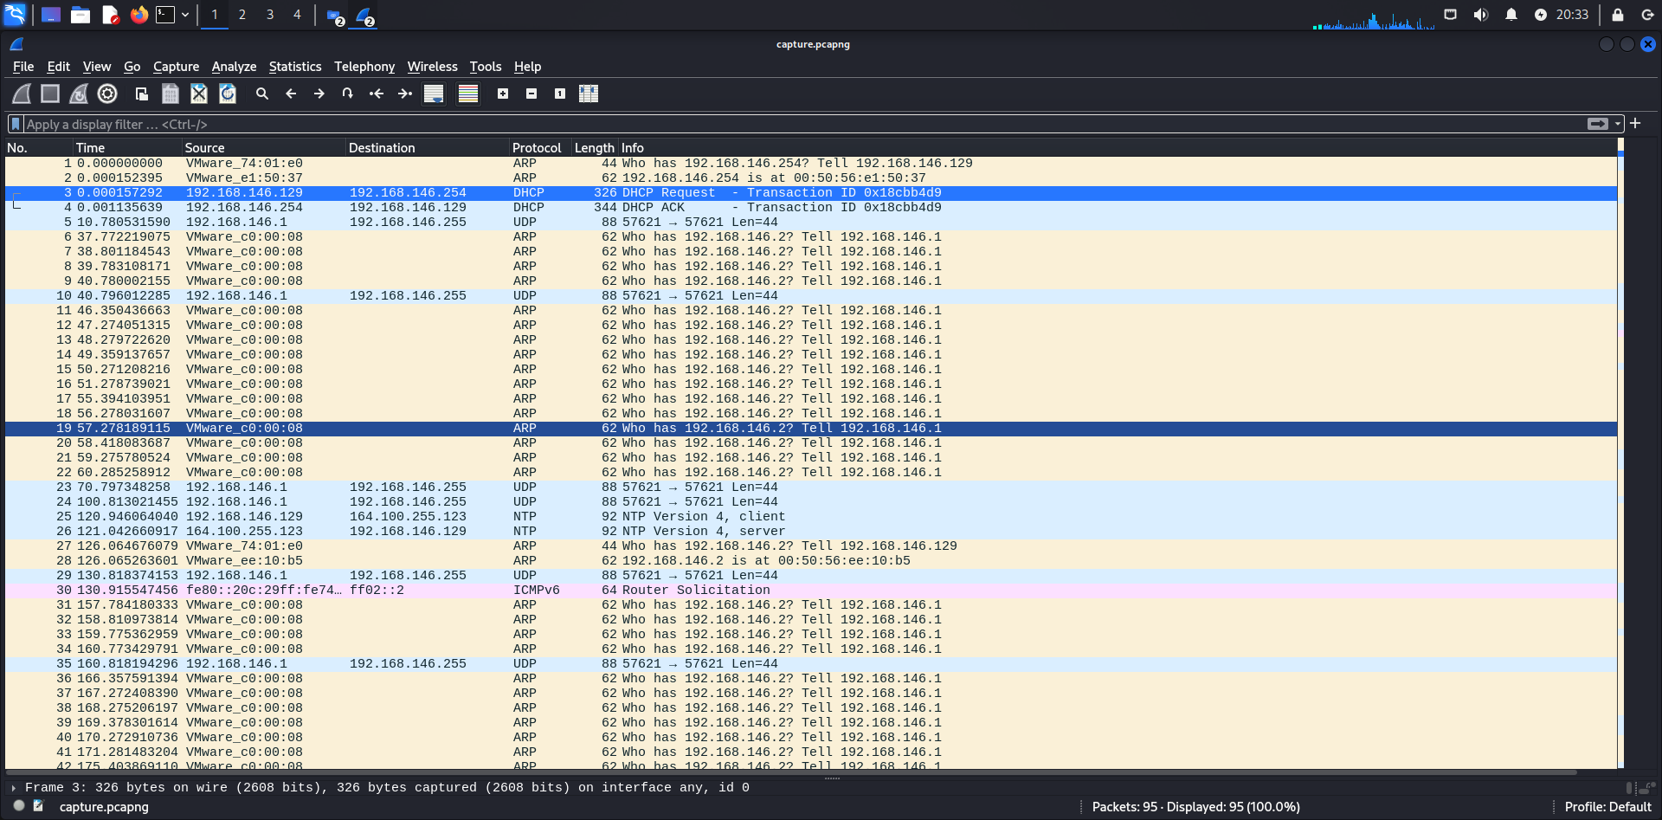

The above data belongs to the network that is vmware because here I would like to show filter works.

Filter: udp

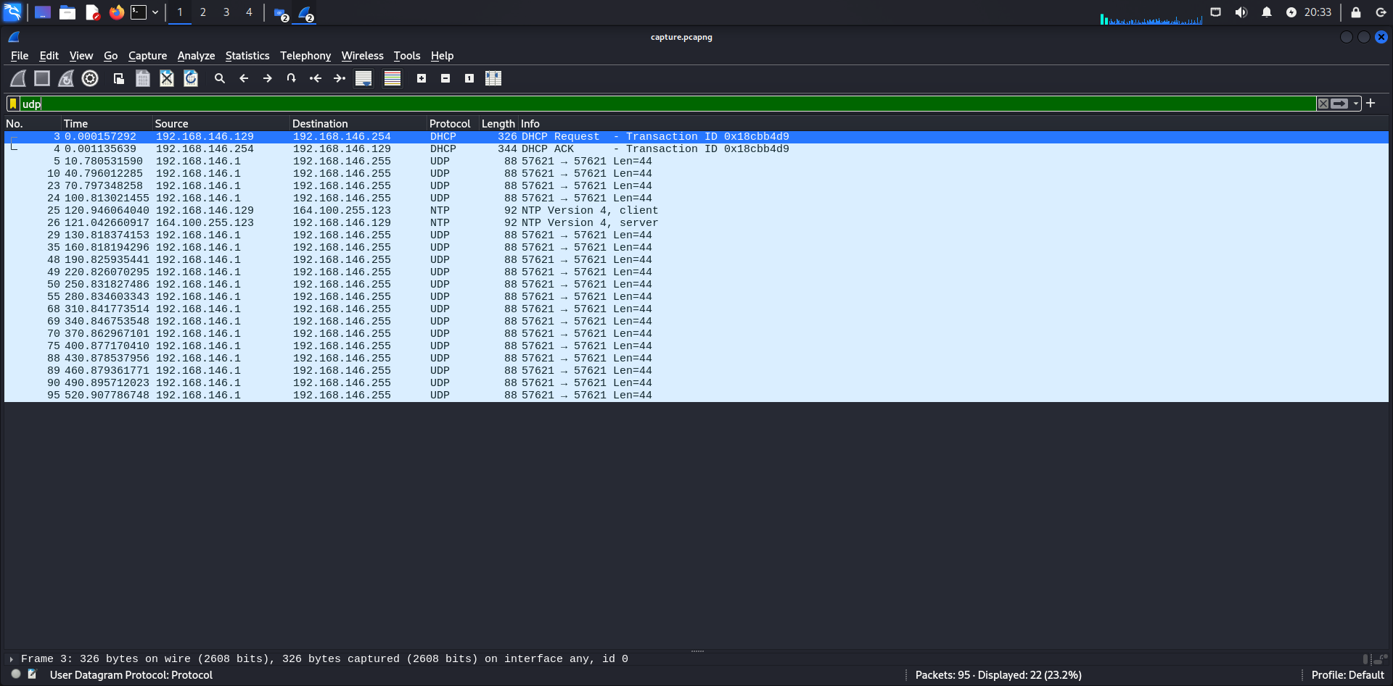

Filter: arp

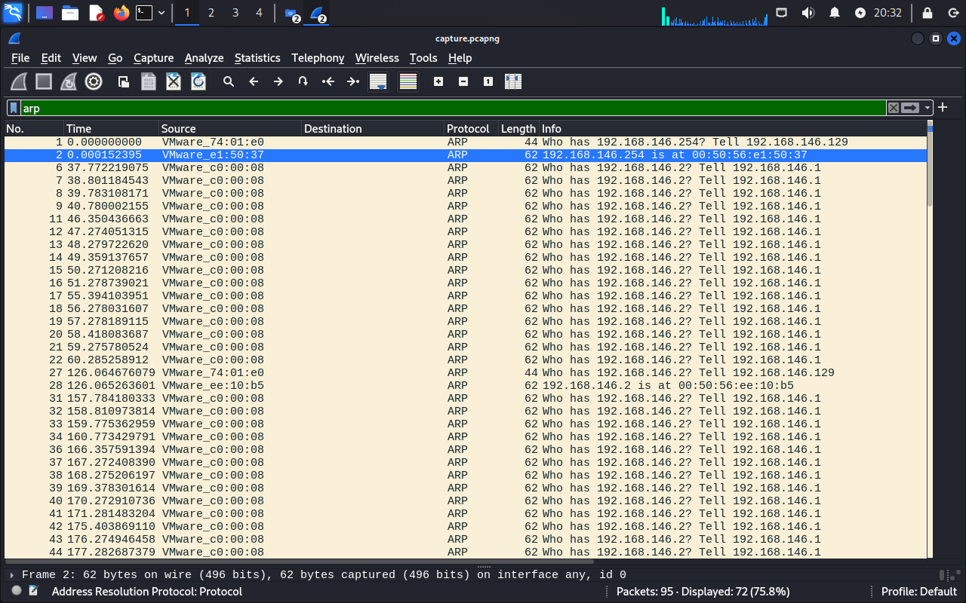

1. **Analysis**: After filtering, you can begin analyzing the packet data. This involves examining the contents of packets to understand the traffic patterns, identify any anomalies, troubleshoot network issues, or investigate security incidents. Analysis can include looking at packet headers, payload contents, and timing information.
2. **Protocol Decoding**: Many packet capture tools can decode various network protocols, allowing you to inspect higher-layer information such as HTTP requests, DNS queries, or SMTP messages. This decoding helps you understand the nature of the traffic and identify any malicious or suspicious activity.
3. **Statistical Analysis**: In addition to examining individual packets, you can also perform statistical analysis on packet data. This might involve looking at traffic patterns over time, identifying trends, calculating packet loss rates, or determining network latency.
4. **Security Monitoring**: Packet analysis is a crucial component of security monitoring. By inspecting packet data, you can detect and investigate security incidents such as intrusion attempts, malware infections, data exfiltration, or denial-of-service attacks.
5. **Visualization**: Many packet analysis tools provide visualization features to help you understand the data more intuitively. Graphs, charts, and diagrams can be used to represent network topology, traffic flows, or attack patterns.
6. **Reporting**: Finally, the findings from packet analysis are often documented in reports. These reports may include summaries of network activity, details of security incidents, recommendations for improving network performance or security, and any other relevant insights.

**Implementing data retention policies and compliance measures:**

1. **Identify Regulatory Requirements**: Start by identifying the relevant regulatory requirements that apply to your organization's industry and geographical location. Regulations such as GDPR (General Data Protection Regulation), HIPAA (Health Insurance Portability and Accountability Act), CCPA (California Consumer Privacy Act), and others may impose specific data retention requirements.
2. **Classify Data**: Classify your organization's data based on its sensitivity, value, and regulatory requirements. Determine which data needs to be retained and for how long. Classify data into categories such as sensitive, confidential, regulated, and non-sensitive.
3. **Develop Data Retention Policies**: Develop data retention policies that specify how long different types of data should be retained and the methods for storing and disposing of data. Consider factors such as legal requirements, business needs, and the risk of data breaches. Document the data retention policies clearly and communicate them to all relevant stakeholders.
4. **Implement Data Storage** Solutions: Implement data storage solutions that support your data retention policies. This may include using on-premises storage systems, cloud storage services, or a combination of both. Ensure that the storage solutions provide adequate security, encryption, and access controls to protect the retained data.
5. **Automate Retention Processes**: Implement automated processes for data retention, including data archiving, backup, and deletion. Use data management tools and software solutions to automate the enforcement of data retention policies and ensure compliance with regulatory requirements. Schedule regular data audits to verify compliance and identify any non-compliant data.
6. **Monitor and Audit Data Access**: Implement monitoring and auditing mechanisms to track data access and usage. Monitor who accesses the retained data, when they access it, and for what purposes. Implement access controls and authentication mechanisms to restrict access to authorized users only.
7. **Ensure Data Security**: Implement robust security measures to protect the retained data from unauthorized access, data breaches, and cyber threats. This may include encryption, data masking, access controls, intrusion detection systems, and security awareness training for employees.
8. **Periodic Review and Updates**: Periodically review and update your data retention policies and compliance measures to ensure they remain effective and up-to-date with changing regulatory requirements and business needs. Regularly assess your data retention practices and make adjustments as necessary.
9. **Employee Training and Awareness**: Provide training and awareness programs for employees to educate them about data retention policies, compliance requirements, and their roles and responsibilities in safeguarding sensitive information. Ensure that employees understand the importance of data retention and compliance with regulatory requirements.

**Alerting And Notification Systems**

Alerting and Notification Systems are essential components of cybersecurity infrastructure designed to promptly inform stakeholders about potential security threats, incidents, or abnormal activities within an organization's network or systems. These systems continuously monitor various securityrelated events, such as unauthorized access attempts, malware infections, or system vulnerabilities, and trigger alerts based on predefined rules or thresholds.

When an alert is triggered, the system notifies designated personnel or teams via various communication channels, such as email, SMS, instant messaging, or integration with collaboration platforms like Slack or Microsoft Teams. The notifications typically include relevant details about the detected event, such as the nature of the threat, affected systems or users, severity level, and recommended actions for mitigation or investigation.

Alerting and Notification Systems play a crucial role in enabling timely incident response, allowing organizations to swiftly address security incidents and minimize their impact. By providing realtime awareness of potential threats, these systems empower security teams to take proactive measures to protect critical assets, maintain business continuity, and safeguard sensitive data from unauthorized access or compromise. Additionally, they help ensure compliance with regulatory requirements by facilitating prompt reporting and documentation of security incidents. Overall, Alerting and Notification Systems are indispensable tools for enhancing cybersecurity posture and resilience in today's dynamic threat landscape.

* Defining Thresholds And Trigger Conditions
* Configuring Alert Rules And Notifications
* Integrating With Incident Response Systems
* Testing Alerting Mechanisms And Escalation Procedures
* Automating Response Actions For Critical Events

1. **Defining Thresholds And Trigger Conditions**

Define thresholds and trigger conditions for generating alerts based on predefined criteria, such as performance thresholds, security policy violations, or anomaly detection rules. Establish threshold values for key metrics and KPIs that indicate abnormal behavior or potential security incidents. Specify trigger conditions, including event correlation rules, pattern recognition algorithms, and statistical analysis techniques, to identify actionable events that warrant alerting.

1. **Thresholds:** These are predefined levels or values that serve as benchmarks for specific metrics or parameters. Thresholds can be numerical values, ranges, percentages, or even qualitative conditions.

2. **Trigger Conditions:** These are the conditions that need to be met or exceeded for an action to be initiated. Trigger conditions are often based on the comparison of current values with predefined thresholds.

3. **Types of Thresholds and Triggers:**

**Absolute Thresholds**: These are fixed values that, when crossed, trigger an action.

**Relative Thresholds**: These are thresholds that are relative to a reference point or baseline.

**Dynamic Thresholds**: These thresholds adjust based on historical data or contextual factors.

**Composite Thresholds**: These are thresholds based on multiple parameters or conditions.

4. **Applications**:

**Monitoring Systems**: Thresholds and triggers are used extensively in monitoring systems for detecting anomalies or critical events.

**Financial Trading**: In algorithmic trading, thresholds and triggers are vital for executing trades based on predefined conditions.

**Network Security**: Intrusion detection systems rely on thresholds and triggers to identify potential security breaches.

**Environmental Monitoring**: Thresholds are set for parameters like pollution levels, triggering actions when limits are exceeded.

5. **Considerations:**

**Accuracy**: Thresholds should be set accurately to avoid false alarms or missed triggers.

**Flexibility**: Thresholds may need periodic adjustment based on changing conditions or requirements.

**Response Time**: Trigger conditions should be designed to initiate actions promptly to mitigate risks or capitalize on opportunities.

**Integration**: Thresholds and triggers should integrate seamlessly with the overall system architecture.

1. **Configuring Alert Rules And Notifications**

Configuring alert rules and notifications using, IBM QRadar involves different processes and tools. Here's an overview of how you can configure:

IBM QRadar is a security information and event management (SIEM) system that allows you to monitor and analyze security events in realtime.

1. Access Rule Configuration: Log in to the IBM QRadar console.

2. Navigate to Rules: Go to the Rules section, where you can define custom rules for detecting security incidents.

3. Create Alert Rules: Define rules based on specific conditions, such as unusual network traffic patterns, known attack signatures, or system vulnerabilities.

4. Set Response Actions: Configure actions to be taken when a rule is triggered, such as generating an offense, sending an email notification, or executing a script.

5. Tune and Test: Finetune the rules to reduce false positives and test them to ensure they are detecting real security threats effectively.

1. **Integrating With Incident Response Systems**

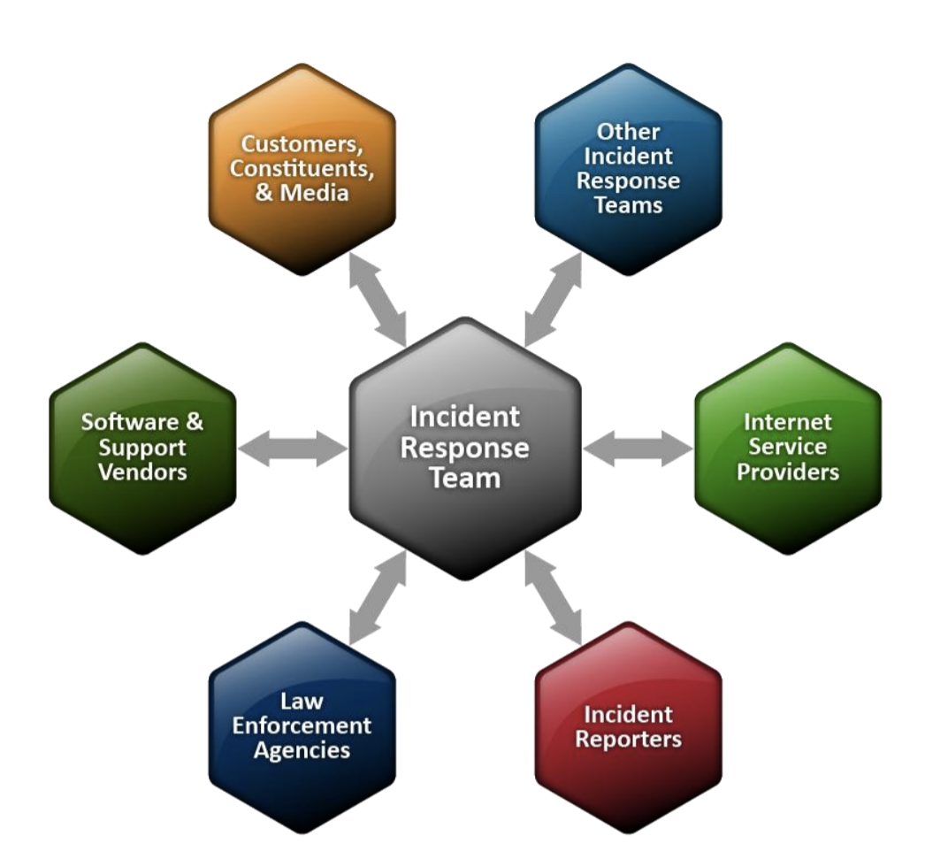

[This Photo](https://kryptera.se/t/dataintrang/) by Unknown Author is licensed under [CC BY](https://creativecommons.org/licenses/by/3.0/)

Integrating alerting systems with incident response systems is crucial for efficiently managing and responding to security incidents. Here's how you can integrate IBM QRadar with incident response systems:

IBM QRadar:

1. Utilize QRadar Offenses: IBM QRadar generates offenses for detected security incidents. You can configure these offenses to trigger specific responses.

2. Integrate with Ticketing Systems: Configure QRadar to integrate with your ticketing system or incident management platform. This allows QRadar to create tickets automatically for detected offenses.

3. Define Response Workflows: Establish response workflows within your incident response system based on QRadar offenses. Define the steps to be taken when certain types of offenses are detected.

4. Enrichment with QRadar Data: Use QRadar's contextual information, such as source IP, destination IP, and event details, to enrich incident data in your incident response system for better analysis and response.

General Considerations:

BiDirectional Communication: Ensure that there is a feedback loop between the alerting system and the incident response system. This allows for the closure of incidents and updates to alerting configurations based on incident outcomes.

Orchestration and Automation: Utilize orchestration and automation tools to streamline incident response processes. This can help in executing response actions quickly and accurately.

Testing and Tuning: Regularly test and tune the integration between alerting and incident response systems to ensure reliability and effectiveness during real incidents.

Integrating these systems enables a more proactive and efficient response to security incidents by automating alert handling and response actions.

Let explain each context of incident response:

1. Utilize SNMP Traps or Syslog:

SNMP Traps (Simple Network Management Protocol): SNMP traps are asynchronous notifications that alert management systems of events and conditions. In the context of an incident response system, devices like network switches, routers, and servers can send SNMP traps to notify about specific events, such as high CPU usage, interface status changes, or securityrelated events.

Syslog: Syslog is a standard for message logging, allowing devices and applications to generate logs of various events. These logs can be sent to a centralized syslog server where they can be analyzed for security incidents. In an incident response system, syslog messages can trigger alerts based on predefined rules.

2. Configure Incident Response System:

An incident response system is a set of processes, tools, and procedures designed to detect, respond to, and recover from security incidents. This system typically includes:

Incident Detection: Mechanisms to identify security incidents, such as intrusion detection systems (IDS), security information and event management (SIEM) systems, or log analysis tools.

Incident Analysis: Tools and procedures for analyzing the nature and scope of security incidents, including forensic analysis, malware analysis, and threat intelligence.

Incident Response: Defined procedures for responding to security incidents, including containment, eradication, and recovery actions.

Communication: Protocols and tools for communication between incident responders, stakeholders, and management during an incident.

3. Map Alerts to Incident Types:

Mapping alerts to incident types involves categorizing alerts based on their severity, type, and potential impact on the organization. For example:

High Priority Incidents: Critical alerts that require immediate action, such as a detected breach or a system outage.

Medium Priority Incidents: Alerts indicating suspicious activity or potential security threats that need investigation but may not require immediate action.

Low Priority Incidents: Alerts that are informational or require no action, such as routine system logs or configuration changes.

Mapping alerts to incident types helps prioritize responses and allocate resources effectively during security incidents.

4. Automate Response Actions:

Automating response actions involves defining and implementing automated workflows to respond to security incidents. This may include:

Automated Containment: Automatically isolating compromised systems or blocking malicious traffic at the network level.

Automated Remediation: Implementing automated remediation actions to restore affected systems to a known good state.

Automated Notification: Automatically notifying stakeholders, such as IT teams, management, or regulatory bodies, about security incidents.

Automating response actions helps reduce response times, minimize human error, and ensure consistent responses to security incidents.

1. **Testing Alerting Mechanisms And Escalation Procedures**

Testing alerting mechanisms and escalation procedures using IBM QRadar involves simulating various scenarios and verifying that the system generates alerts and escalates them according to predefined policies. Here's how you can do it:

1. **Define Test Scenarios:**

Performance Degradation:

Simulate scenarios where critical systems experience performance degradation, such as high CPU or memory usage, network congestion, or application slowdowns.

Security Breaches:

Create simulated security breach scenarios, such as unauthorized access attempts, malware infections, or data exfiltration incidents.

Compliance Violations:

Test for compliance violations by intentionally triggering events that violate regulatory requirements or internal policies, such as unauthorized access to sensitive data or configuration changes that breach compliance standards.

2. **Configure Test Environment:**

Set up a test environment that mirrors your production environment, including IBM QRadar SIEM, relevant network devices, servers, and applications.

Ensure that logs and events from all systems are being ingested into QRadar for analysis.

3. **Create Custom Rules and Offenses:**

Performance Degradation:

Define custom rules in QRadar to detect performancerelated events, such as high CPU usage or network latency.

Security Breaches:

Configure rules to detect security breach events, such as failed login attempts, suspicious network traffic, or known malware signatures.

Compliance Violations:

Create rules to monitor for compliance violations, such as unauthorized access to sensitive data or configuration changes that violate policies.

4. **Execute Test Scenarios:**

Performance Degradation:

Simulate performance degradation by increasing CPU or memory usage on test systems.

Verify that QRadar generates offenses based on the defined rules for performance degradation.

Security Breaches:

Trigger security breach events, such as brute force login attempts or malware activity, on test systems.

Confirm that QRadar generates offenses for these security incidents.

Compliance Violations:

Intentionally violate compliance policies, such as accessing restricted data or making unauthorized configuration changes.

Ensure that QRadar generates offenses for compliance violations.

5. **Validate Alert Notifications:**

Verify that alerts are triggered and displayed in the QRadar console promptly after the corresponding offenses are generated.

Test different notification channels (email, SMS, etc.) to ensure alerts are delivered to designated recipients.

6. **Test Escalation Procedures:**

Test escalation procedures by delaying acknowledgment or response to alerts to verify that escalation policies are triggered when necessary.

Confirm that alerts are escalated to the appropriate individuals or teams based on predefined escalation paths and levels.

7. **Monitor and Analyze Results:**

Monitor the QRadar console to capture any missed alerts, delayed notifications, or incorrect escalations.

Analyze the test results to evaluate the effectiveness and reliability of QRadar's alerting and escalation capabilities.

8. **Address Gaps and Document:**

Address any identified gaps or inefficiencies in the alerting process by adjusting rules, refining escalation policies, or improving the configuration of QRadar.

Document the test results, including observations, findings, and any corrective actions taken.

1. **Automating Response Actions For Critical Events**

To automate response actions for critical events using IBM QRadar and craft a customized solution, follow these steps:

1. Define Critical Events:

Identify the critical events and security incidents that require automated responses. These could include:

Malicious activities such as unauthorized access attempts or malware infections.

Policy violations such as unauthorized data access or configuration changes.

Performance degradation or system outages.

2. Define Response Actions:

Blocking Malicious IP Addresses:

Use QRadar's offense rules to detect malicious IP addresses.

Utilize an orchestration tool or firewall API to automatically block the malicious IP addresses.

Quarantining Infected Hosts:

Configure QRadar to detect indicators of compromised hosts, such as unusual network traffic or known malware signatures.

Integrate with endpoint security solutions or network access control (NAC) systems to quarantine infected hosts automatically.

Isolating Compromised Systems:

Set up QRadar rules to identify compromised systems based on behavior analytics or security events.

Integrate with network infrastructure devices (e.g., switches, routers) to isolate compromised systems by disabling network ports or moving them to a separate VLAN.

3. Develop Response Playbooks:

Create response playbooks that outline the sequence of actions to be taken in response to each critical event.

Include details such as the trigger conditions, response actions, responsible parties, and escalation procedures.

4. Integrate with Orchestration and Automation Tools:

Use QRadar's Integration Capabilities:

Utilize QRadar's APIs to trigger automated response actions or to send alerts to external orchestration tools.

Orchestration Tools:

Integrate QRadar with orchestration tools like IBM Resilient, Demisto, or Phantom to orchestrate response actions across your security infrastructure.

Define workflows in these tools to automate response actions based on QRadar alerts.

5. Monitor and Audit Automated Response Actions:

Implement monitoring and auditing mechanisms to track the execution of automated response actions.

Monitor the effectiveness of response actions and ensure that they are triggered and executed as expected.

Audit the automated response actions regularly to ensure compliance with security policies and regulatory requirements.

6. Testing and Validation:

Test the automated response actions in a controlled environment to verify that they function correctly.

Validate that response actions are triggered promptly and accurately in response to critical events and security incidents.

7. Continuous Improvement:

Continuously review and update response playbooks and automated response actions based on lessons learned from incident response activities.

Stay updated on emerging threats and adjust response actions accordingly to improve the effectiveness of your incident response process.

Alerting :

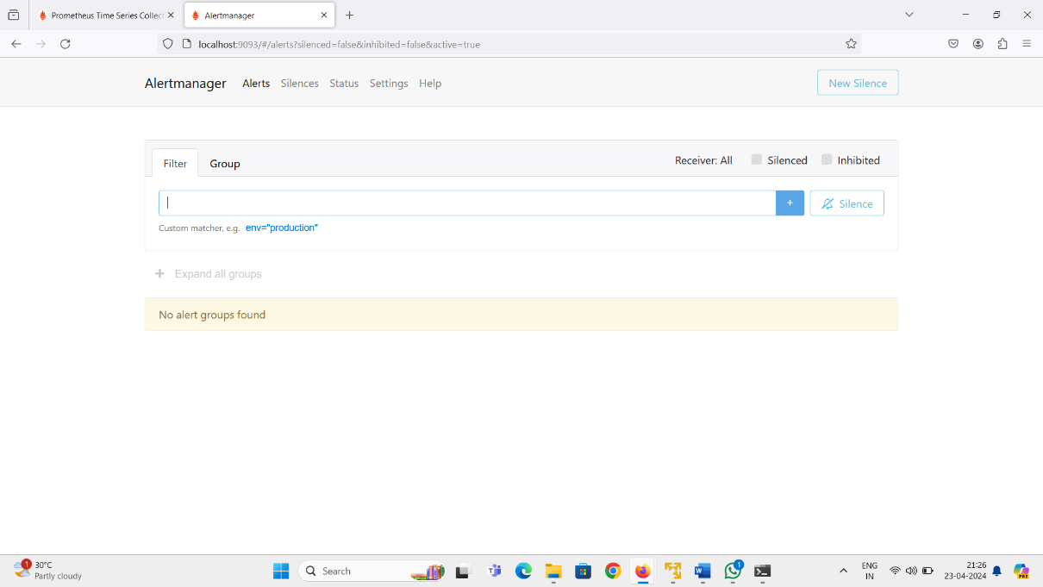

Notification:

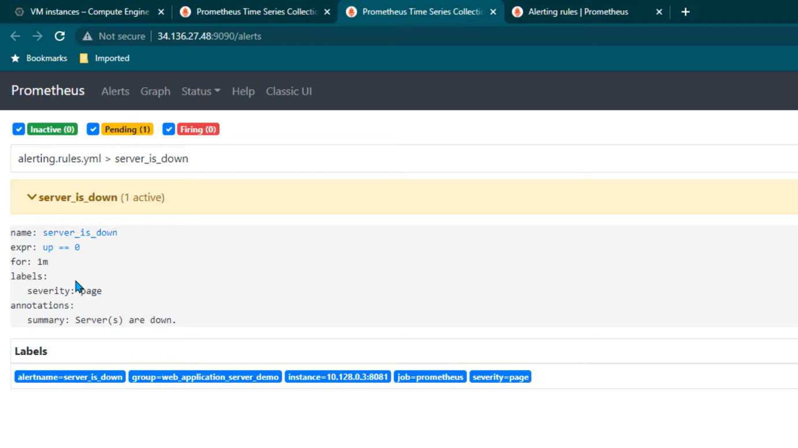

**Stage-3: Monitoring,maintenance,And Optimization**

**Monitoring, Maintenance, And Optimization**

Establishing comprehensive monitoring processes and procedures is crucial for maintaining the effectiveness and reliability of a monitoring solution, particularly when leveraging platforms like QRadar. To achieve this, organizations employ a variety of tools and technologies tailored to each phase of the monitoring lifecycle.

**Monitoring Tools:**

**1. System Monitoring Tools:**

**Prometheus**: Known for its robust time-series database and flexible querying language, ideal for monitoring dynamic infrastructure environments.

**2. Network Monitoring Tools:**

**Cisco Prime Infrastructure**: Tailored for Cisco network environments, offering centralized monitoring and management capabilities for network devices.

**3. Security Information and Event Management (SIEM) Tools:**

**IBM QRadar**: A powerful SIEM solution capable of collecting, correlating, and analyzing security event data from various sources to detect and respond to security threats.

**Maintenance Tools:**

**1. Patch Management Tools:**

**Microsoft WSUS (Windows Server Update Services):** Allows centralized management and deployment of software updates and security patches for Windows systems.

**2. Configuration Management Tools:**

**Ansible**: An automation tool that enables configuration management, application deployment, and orchestration of IT infrastructure through playbooks and modules.

**Optimization Tools:**

**1. Performance Monitoring and Optimization Tools:**

**AppDynamics**: Delivers real-time insights into application performance, user experience, and business impact to optimize performance and ensure business continuity.

**2. Resource Management Tools:**

**AWS Auto Scaling**: Automatically adjusts compute capacity based on demand to optimize resource utilization and cost efficiency in AWS cloud environments.

By leveraging these tools across the monitoring, maintenance, and optimization phases, organizations can establish robust processes and procedures for managing and enhancing the performance, reliability, and security of their IT systems, networks, and infrastructure with QRadar.

**Establishing Monitoring Processes and Procedures with IBM QRadar**

In today's rapidly evolving IT landscape, ensuring the ongoing effectiveness and reliability of a monitoring solution is paramount for organizations aiming to safeguard their systems, networks, and infrastructure. Crafting a customized monitoring solution with IBM QRadar entails the development of comprehensive processes and procedures tailored to the unique needs and challenges of the organization. By documenting standard operating procedures (SOPs) for monitoring setup, configuration, data collection, analysis, and reporting, organizations can establish a structured framework to maximize the value and capabilities of their monitoring solution. Additionally, defining roles and responsibilities for monitoring team members and establishing clear communication channels for incident escalation and resolution are critical components of an effective monitoring strategy. This article delves into the intricacies of crafting a customized monitoring solution with IBM QRadar, providing insights into the key processes, procedures, roles, and responsibilities involved.

**Monitoring Setup and Configuration:**

The foundation of a robust monitoring solution lies in its setup and configuration. Organizations must conduct a comprehensive assessment of their IT environment to identify the scope of monitoring requirements. This involves evaluating the systems, networks, and infrastructure components that need to be monitored to ensure proactive detection and response to potential security threats and performance issues. Once the monitoring requirements are identified, the next step is to install and configure IBM QRadar according to best practices and manufacturer guidelines. This includes setting up data sources such as logs, events, and network flows to be ingested by QRadar for analysis. Proper configuration of rules within QRadar is essential to detect security incidents and anomalies based on the organization's security policies. Integration with other security tools and systems further enhances the correlation and threat intelligence capabilities of QRadar, enabling organizations to gain comprehensive visibility into their security posture.

**Data Collection and Analysis:**

Effective data collection and analysis are critical components of a monitoring solution. QRadar continuously collects and processes data from configured data sources, including logs, events, and network flows, to provide real-time insights into the operational status of the IT environment. Normalization of incoming data ensures consistency and compatibility for analysis within QRadar, enabling organizations to correlate events from multiple sources and identify potential security incidents. Anomaly detection rules are configured to identify unusual behavior or patterns that may indicate security threats, while integration with threat intelligence feeds enhances the detection of known threats. By leveraging QRadar's powerful correlation engine and analytics capabilities, organizations can proactively detect and respond to security incidents, minimizing the risk of data breaches and operational disruptions.

**Reporting:**

Reporting is an essential aspect of monitoring, providing stakeholders with actionable insights into security events, incidents, and trends. QRadar's reporting capabilities allow organizations to generate regular and ad-hoc reports tailored to the specific requirements of different stakeholders, including management, IT teams, and auditors. Customization of reports enables organizations to highlight key metrics, trends, and areas for improvement, facilitating informed decision-making and resource allocation. Distribution of reports through various channels such as email, web portals, or dashboards ensures timely access to critical information, while analysis of reports enables organizations to identify patterns, trends, and areas for optimization in their security posture. By leveraging QRadar's reporting capabilities, organizations can demonstrate compliance with regulatory requirements, track performance against key performance indicators (KPIs), and continuously improve their security posture.

**Roles and Responsibilities:**

Clear delineation of roles and responsibilities is essential for the effective operation of a monitoring solution. Security analysts play a crucial role in monitoring security events and incidents, investigating alerts, and escalating as necessary. System administrators are responsible for the setup, configuration, and maintenance of the QRadar system, ensuring its ongoing effectiveness and reliability. The incident response team is tasked with responding to and resolving security incidents in a timely manner, minimizing the impact on the organization's operations. Management provides oversight, guidance, and support to the monitoring team, making decisions regarding resource allocation, prioritization, and strategic direction. By defining clear roles and responsibilities, organizations can ensure accountability, efficiency, and collaboration within the monitoring team, enabling them to effectively detect, respond to, and mitigate security threats and incidents.

**Incident Escalation and Resolution:**

Establishing clear communication channels for incident escalation and resolution is critical for minimizing the impact of security incidents on the organization's operations. A tiered escalation process with defined thresholds ensures timely escalation of security incidents to higher levels of management or specialized teams for resolution. Clear communication channels, including phone, email, and incident management tools, enable efficient coordination and collaboration among team members during incident response activities. Enforcing service level agreements (SLAs) for incident response and resolution ensures timely handling of security incidents, minimizing the risk of data breaches and operational disruptions. Post-incident reviews are conducted to identify root causes, lessons learned, and areas for improvement in the incident response process, enabling organizations to continuously enhance their incident response capabilities and resilience.

**Performing Regular Health Checks And Audits**

Performing regular health checks and audits of the monitoring infrastructure is imperative to maintain the effectiveness and reliability of the monitoring solution with IBM QRadar. These proactive measures enable organizations to identify potential issues, performance bottlenecks, and configuration errors before they escalate into critical problems that could impact the organization's security posture and operational efficiency. By scheduling periodic assessments of QRadar components, data sources, and integration points, organizations can ensure the optimal functionality and data accuracy of their monitoring environment.

**Regular Health Checks and Audits:**

Regular health checks and audits involve systematic evaluations of the monitoring infrastructure to assess its overall health and performance. This includes examining the hardware and software components of the QRadar system, verifying the integrity of data sources and configuration settings, and identifying any discrepancies or anomalies that may indicate potential issues. Health checks may encompass various aspects of the monitoring environment, such as system availability, resource utilization, database performance, and event processing capabilities. Audits, on the other hand, focus on verifying the adherence of the monitoring solution to industry standards, best practices, and regulatory requirements.

**Schedule Periodic Assessments:**

To ensure the ongoing effectiveness of the monitoring solution, organizations should schedule periodic assessments of QRadar components, data sources, and integration points. These assessments can be conducted at regular intervals, such as weekly, monthly, or quarterly, depending on the organization's operational requirements and risk profile. During these assessments, IT teams should systematically review the configuration settings, event processing rules, and data retention policies within QRadar to ensure they align with the organization's security objectives and compliance requirements. Additionally, data sources should be monitored for consistency, accuracy, and completeness to ensure that relevant security events are captured and processed effectively.

**Vulnerability Scans and Security Assessments:**

In addition to health checks and audits, organizations should perform vulnerability scans and security assessments of the monitoring infrastructure to identify potential security risks and vulnerabilities. Vulnerability scanning tools can help detect known security vulnerabilities in QRadar components, operating systems, and network devices, allowing IT teams to prioritize and remediate these issues promptly. Security assessments involve evaluating the effectiveness of security controls, access controls, and encryption mechanisms within the monitoring environment to mitigate the risk of unauthorized access, data breaches, and insider threats.

**Compliance Audits:**

Maintaining regulatory compliance is a critical aspect of managing a monitoring solution, particularly in industries subject to stringent data protection and privacy regulations. Organizations should conduct regular compliance audits to ensure that the monitoring infrastructure meets the requirements of relevant regulatory frameworks, such as GDPR, HIPAA, PCI DSS, and SOX. Compliance audits involve assessing the adequacy of security controls, data encryption practices, audit logging mechanisms, and incident response procedures within the monitoring environment to demonstrate adherence to regulatory standards and mitigate the risk of non-compliance-related penalties and sanctions.

**Conducting Performance Tuning And Optimization**

Conducting performance tuning and optimization is crucial for maximizing the effectiveness and efficiency of a monitoring solution with IBM QRadar. Through continuous optimization efforts, organizations can fine-tune QRadar configurations, rule sets, and data processing parameters to minimize false positives, enhance detection accuracy, and reduce resource consumption. By implementing caching mechanisms, data aggregation techniques, and query optimization strategies, organizations can improve system responsiveness, scalability, and overall performance.

**Performance Tuning and Optimization Strategies:**

Performance tuning and optimization involve a systematic approach to optimizing the performance and efficiency of the monitoring solution. This includes identifying performance bottlenecks, analyzing system metrics, and implementing targeted optimization strategies to address identified issues. Organizations should adopt a proactive approach to performance tuning, continuously monitoring system performance and making adjustments as needed to maintain optimal operation.

**Fine-tune QRadar Configurations:**

Fine-tuning QRadar configurations involves optimizing settings related to data collection, processing, and storage to improve system performance and resource utilization. This includes configuring data source properties, event retention policies, and log source protocols to align with the organization's monitoring requirements and objectives. By fine-tuning QRadar configurations, organizations can optimize data processing workflows, reduce storage overhead, and improve the overall efficiency of the monitoring solution.

**Optimize Rule Sets:**

Rule sets play a crucial role in detecting security incidents and anomalies within the monitored environment. However, poorly configured or overly broad rule sets can lead to an influx of false positives, overwhelming security analysts and reducing the effectiveness of the monitoring solution. To optimize rule sets, organizations should review and refine existing rules, removing outdated or redundant rules and fine-tuning rule parameters to improve detection accuracy. Additionally, organizations should leverage QRadar's advanced rule testing capabilities to validate rule effectiveness and identify opportunities for optimization.

**Implement Caching Mechanisms:**

Caching mechanisms can significantly improve the performance and responsiveness of the monitoring solution by storing frequently accessed data in memory for rapid retrieval. By implementing caching mechanisms, organizations can reduce the latency associated with data retrieval and processing, enhancing system responsiveness and scalability. QRadar supports caching mechanisms for frequently accessed data sources, enabling organizations to optimize performance and improve overall system efficiency.

**Utilize Data Aggregation Techniques:**

Data aggregation techniques involve consolidating and summarizing large volumes of data to reduce storage requirements and improve query performance. By aggregating data at various levels of granularity, organizations can streamline data processing workflows and optimize resource utilization. QRadar offers built-in support for data aggregation techniques, allowing organizations to aggregate and analyze data more efficiently, improving system performance and scalability.

**Query Optimization Strategies:**

Query optimization strategies involve optimizing database queries and data retrieval processes to improve query performance and reduce resource consumption. By optimizing query execution plans, indexing key fields, and implementing efficient data retrieval algorithms, organizations can minimize query latency and enhance overall system performance. QRadar provides tools and utilities for query optimization, enabling organizations to fine-tune database performance and optimize data retrieval processes.

**Implementing system updates and patch management**

Implementing system updates and patch management is paramount for maintaining the security, stability, and reliability of a monitoring solution with IBM QRadar. By staying up-to-date with the latest software updates, patches, and security fixes released by IBM, organizations can mitigate vulnerabilities, address known issues, and enhance system stability. Establishing a systematic approach to system updates and patch management involves developing a comprehensive strategy that encompasses patch identification, testing, deployment, and monitoring.

**Patch Management Strategy:**

A robust patch management strategy begins with establishing a clear understanding of the organization's patch management requirements and objectives. This involves identifying critical systems, applications, and components that require regular patching to mitigate security risks and maintain system integrity. By prioritizing patches based on severity, impact, and relevance to the organization's environment, organizations can focus their patch management efforts on addressing the most critical vulnerabilities and ensuring timely deployment of security updates.

**Patch Identification:**

Effective patch management begins with the timely identification of available patches and security updates for IBM QRadar. Organizations should actively monitor vendor announcements, security advisories, and release notes to stay informed about the latest patches and updates released by IBM. Automated patch management tools and vulnerability scanners can assist in identifying missing patches and assessing the overall patch status of the monitoring environment. By maintaining a proactive approach to patch identification, organizations can ensure they are aware of critical vulnerabilities and security updates that may impact the security and performance of their monitoring solution.

**Patch Testing:**

Before deploying patches to production systems, it is essential to test them in a controlled environment to assess their impact on system stability and functionality. Organizations should establish a patch testing process that includes replicating production environments, applying patches to test systems, and conducting comprehensive testing to evaluate the compatibility and effectiveness of the patches. This testing phase helps identify any potential issues or conflicts introduced by the patches and allows organizations to mitigate risks associated with patch deployment. By testing patches in a controlled environment, organizations can minimize the risk of unexpected downtime or disruptions to critical systems during the patch deployment process.

**Patch Deployment:**

Once patches have been tested and validated, organizations can proceed with deploying them to production systems. A structured patch deployment process involves scheduling patch installations during planned maintenance windows to minimize disruptions to business operations. Organizations should follow best practices for patch deployment, including taking backups of critical systems, documenting patch installation procedures, and monitoring patch deployment progress to ensure successful completion. Automated patch deployment tools can streamline the patch deployment process and provide centralized management of patch installations across distributed environments. By adhering to a structured patch deployment process, organizations can minimize the risk of security vulnerabilities and ensure the timely implementation of critical security updates.

**Patch Monitoring and Verification:**

After patches have been deployed, it is essential to monitor the monitoring environment for any signs of issues or anomalies that may have been introduced by the patches. Organizations should establish monitoring mechanisms to track system performance, stability, and security following patch deployment. This includes monitoring system logs, event alerts, and performance metrics to identify any unusual behavior or indicators of potential issues. Additionally, organizations should verify that patches have been successfully applied to all relevant systems and components and that the monitoring environment remains secure and stable. Regular monitoring and verification of patch status help ensure the ongoing effectiveness and reliability of the monitoring solution and enable organizations to respond promptly to any issues that may arise.

**Continuous Training And Knowledge Transfer For Monitoring Team**

Continuous training and knowledge transfer are integral components of maintaining a high-performing monitoring team equipped with the skills and expertise necessary to effectively operate and maintain IBM QRadar. Investing in comprehensive training programs, workshops, and certifications empowers team members with the knowledge and capabilities required to proficiently handle QRadar administration, packet analysis, threat detection, and incident response. By fostering a culture of continuous learning, collaboration, and knowledge sharing within the monitoring team, organizations can harness collective expertise to drive continuous improvement and innovation in their monitoring practices.

**Continuous Training Initiatives:**

Continuous training initiatives play a pivotal role in ensuring that monitoring team members remain abreast of the latest developments, best practices, and techniques in QRadar administration and security operations. Organizations should invest in ongoing training programs tailored to the specific needs and skill levels of their monitoring team members. These programs may include formal classroom training, online courses, workshops, webinars, and hands-on labs covering various aspects of QRadar functionality, configuration, and troubleshooting. By providing continuous training opportunities, organizations empower their monitoring team members to expand their knowledge, refine their skills, and stay up-to-date with evolving industry trends and technologies.

**Comprehensive Workshops and Certifications:**

In addition to general training programs, organizations should offer comprehensive workshops and certifications focused specifically on QRadar administration, packet analysis, threat detection, and incident response. These workshops and certifications provide monitoring team members with in-depth knowledge and practical experience in using QRadar to detect, analyze, and respond to security threats and incidents effectively. Certifications such as the IBM QRadar Certified Administrator and IBM QRadar Certified Deployment Professional validate the expertise and proficiency of monitoring team members in deploying, configuring, and managing QRadar environments. By obtaining relevant certifications, monitoring team members enhance their credibility and demonstrate their commitment to excellence in QRadar administration and security operations.

**Fostering a Culture of Continuous Learning and Collaboration:**

A culture of continuous learning, collaboration, and knowledge sharing is essential for fostering innovation and driving continuous improvement within the monitoring team. Organizations should encourage monitoring team members to actively participate in knowledge-sharing sessions, technical forums, and community events where they can exchange ideas, share experiences, and learn from each other's expertise. Collaborative learning initiatives such as peer mentoring, cross-training programs, and collaborative projects enable monitoring team members to leverage collective knowledge and skills to solve complex problems and enhance their proficiency in QRadar administration and security operations. By fostering a culture of continuous learning and collaboration, organizations cultivate a dynamic and resilient monitoring team capable of adapting to evolving security challenges and driving innovation in their monitoring practices.

**Measuring and Evaluating Training Effectiveness:**

To ensure the effectiveness of training initiatives, organizations should establish metrics and key performance indicators (KPIs) to measure the impact of training on monitoring team performance and effectiveness. This may include tracking metrics such as incident response times, threat detection rates, and resolution efficiency before and after training interventions to assess improvements in team performance. Additionally, organizations should solicit feedback from monitoring team members to gather insights into the effectiveness of training programs, identify areas for improvement, and refine training initiatives to better meet the needs and expectations of team members. By continuously measuring and evaluating training effectiveness, organizations can optimize their training programs to maximize the impact on monitoring team performance and effectiveness.

**Conclusion:**

Crafting a customized monitoring solution that integrates tools like Wireshark, Prometheus, and QRadar offers organizations a comprehensive approach to cybersecurity and network performance monitoring. By combining the packet analysis capabilities of Wireshark with the metrics collection and alerting features of Prometheus and QRadar's robust SIEM platform, organizations can achieve unparalleled visibility into their network activity and performance.

Wireshark, known for its deep packet inspection capabilities, provides granular insights into network traffic, allowing organizations to identify potential security threats and performance bottlenecks. By integrating Wireshark into the monitoring solution, network administrators can capture and analyze packets in real-time, enabling them to detect anomalies, troubleshoot issues, and ensure optimal network performance.

Prometheus, with its powerful time-series database and flexible querying language, complements Wireshark by collecting and aggregating metrics from various sources across the network. By ingesting data from network devices, servers, and applications, Prometheus enables organizations to monitor key performance indicators and set up alerts for abnormal behavior. Integrating Prometheus into the monitoring solution enhances the ability to detect and respond to performance degradation or network anomalies before they impact operations.

QRadar, as a leading SIEM platform, adds another layer of security intelligence to the monitoring solution. By correlating logs, events, and network data from multiple sources, including Wireshark and Prometheus, QRadar provides advanced threat detection and incident response capabilities. It can identify suspicious activities, prioritize alerts based on severity, and automate response actions to mitigate potential security risks. Integrating QRadar into the monitoring solution ensures that security teams have the visibility and context needed to respond effectively to cyber threats.

Moreover, by customizing this integrated monitoring solution with QRadar, organizations can tailor it to their specific security and compliance requirements. QRadar's extensive set of out-of-the-box rules and custom rule capabilities allow organizations to define alerts and policies that align with industry regulations and best practices. Additionally, QRadar's network performance monitoring features enable organizations to track and analyze network traffic patterns, bandwidth utilization, and application performance, further enhancing their overall cybersecurity posture.

In conclusion, crafting a customized monitoring solution with Wireshark, Prometheus, and QRadar offers organizations a powerful framework for comprehensive cybersecurity and network performance monitoring. By integrating these tools, organizations can gain deep visibility into their network activity, detect and respond to security threats in real-time, and ensure optimal performance across their digital infrastructure. As cybersecurity threats continue to evolve, organizations that invest in customized monitoring solutions will be better equipped to protect their assets and maintain the integrity of their networks.

**Future Scope:**

Crafting a customized monitoring solution with QRadar holds immense potential for the future, particularly in the realm of cybersecurity. As organizations grapple with increasingly sophisticated cyber threats, the need for robust and tailored monitoring systems becomes ever more pressing. QRadar, IBM's security information and event management (SIEM) platform, offers a powerful suite of tools for threat detection, incident response, and compliance management. By leveraging QRadar's capabilities and customizing them to specific organizational needs, businesses can fortify their defenses and stay ahead of emerging threats.

One of the key advantages of crafting a customized monitoring solution with QRadar lies in its ability to adapt to the unique requirements of different industries and organizations. Whether it's a financial institution, a healthcare provider, or a manufacturing company, each sector faces distinct cybersecurity challenges and compliance obligations. By tailoring QRadar to address these specific needs, organizations can ensure that their monitoring efforts are precisely aligned with their business objectives and regulatory requirements. This not only enhances security posture but also streamlines operations by focusing resources where they are most needed.

Furthermore, the future scope of customized QRadar monitoring solutions extends beyond traditional cybersecurity concerns. With the proliferation of Internet of Things (IoT) devices and the increasing digitization of critical infrastructure, there is a growing need to monitor a wider range of assets and data sources. QRadar's extensible architecture allows organizations to integrate diverse data feeds, including logs, network traffic, and system events, into a unified monitoring platform. By customizing QRadar to incorporate IoT data streams, organizations can detect and respond to anomalies and security threats across their entire digital ecosystem.

Another area of future growth for customized QRadar solutions lies in advanced analytics and machine learning. As cyber threats become more sophisticated and dynamic, traditional rule-based approaches to threat detection may no longer suffice. By integrating machine learning algorithms into QRadar, organizations can augment their detection capabilities and identify anomalous behavior that may evade conventional security measures. Customizing QRadar with machine learning models tailored to the organization's specific environment and threat landscape can significantly enhance its ability to detect and respond to emerging threats in real-time.

Moreover, the future of cybersecurity is increasingly focused on proactive threat hunting rather than reactive incident response. Customized QRadar solutions can empower security teams to take a proactive stance by providing them with the tools and insights needed to identify and investigate potential threats before they escalate into full-blown incidents. By combining QRadar's rich data analysis capabilities with human expertise, organizations can uncover hidden threats, anticipate attackers' tactics, and preemptively shore up their defenses.

Additionally, the future of QRadar lies in its integration with emerging technologies such as cloud computing and DevOps practices. As organizations migrate more of their infrastructure to the cloud and adopt agile development methodologies, the need for seamless security monitoring across hybrid environments becomes paramount. Customized QRadar solutions can bridge the gap between on-premises and cloud-based assets, providing continuous visibility and control regardless of where the data resides. By incorporating DevOps-friendly features into QRadar, such as automated deployment pipelines and containerization support, organizations can ensure that security is built into the development process from the ground up.

Furthermore, as regulatory requirements continue to evolve and tighten, customized QRadar solutions can play a crucial role in helping organizations achieve compliance. By tailoring QRadar's reporting and alerting capabilities to meet specific regulatory standards, such as GDPR or HIPAA, organizations can demonstrate due diligence and avoid costly fines. Moreover, by proactively monitoring for compliance violations and security gaps, organizations can mitigate the risk of data breaches and reputational damage.

**Reference**

1. [**https://www.wireshark.org/**](https://www.wireshark.org/)
2. [**https://prometheus.io/**](https://prometheus.io/)
3. ibm.com/security/QRadar